Carbon Accounting Systems
Environmental Defense Fund
University of California at Santa Cruz
EDF Climate Corps 2015
August 2nd, 2015

Written by
Thomas LaPoint
St. Edward’s University, Master of Science, Enviornmental Management and Sustainability Candidate, Class of 2015
530-295-7941
Tjlapoin57@gmail.com

EDF Climate Corps (edfclimatecorps.org) taps the talents of tomorrow’s leaders to save energy, money and the environment by placing specially-trained EDF fellows in companies, cities and universities as dedicated energy problem solvers. The following report is the result of a <number (e.g. 10)> week Climate Corps fellowship at <organization name>.
Executive Summary
President Janet Napolitano of the University of California recently issued a commitment to the Carbon Neutrality Initiative for the UC system by 2025. The ten universities within the system have created robust carbon inventories to measure their carbon emissions. They are now tasked with pursuing carbon reduction strategies to reach the Carbon Neutrality Initiative. One strategy of particular interest and the focus of this research is carbon accounting systems. Carbon accounting systems can take the forms of carbon taxes, cap and trade systems and reduction incentive programs. There are currently a few varied models of carbon accounting systems that have achieved success in reducing carbon emissions in the private and public sector. This research paper is an analysis of these carbon accounting systems and how they might apply to public higher education institutions. The University of California at Santa Cruz is used as a case study for this research in collaboration with the University of California Office of the President and the Environmental Defense Fund. There are currently no operational comprehensive carbon accounting or tax systems within higher education, public or private, that pose as a model for this research leading this report to be explorative in nature. Effectiveness and feasibility were both studied when analyzing financial structures, target audiences, applicability and likelihood of implementation. Public universities pose unique challenges in navigating taxpayer funds, diverse stakeholder involvement and behavior change effectiveness. Private corporations use different financial structures in their carbon accounting systems that would require a dramatic overhaul in the current public system’s financial structure to become effective. Universal taxation in existing public systems does not address the inequality of emission sources and who is responsible in the public university. Incentive programs appear to be the most applicable of the models but would gain value with borrowing certain qualities from the other models such as carbon shadow pricing. Climate disturbance does not appear to be slowing making it imperative that this research lead to further research and action to explore this dynamic vehicle of carbon reduction and behavior change.

Keywords: University of California, Carbon Neutrality Initiative, Carbon Accounting, Carbon Tax, University of California at Santa Cruz, behavior change, higher education, climate disturbance

Carbon Accounting
According to the IPPC and 97% of climate scientists, our global climate is changing and the dominant trend is a warming of our atmosphere. This is the result of certain gases trapping heat in our atmosphere. These gases are commonly referred to greenhouse gases (GHG), as they provide the same heating effect that the glass roof of a greenhouse creates. There are four types of greenhouse gases that are responsible for for the majority of this global climate disruption. These gases include carbon dioxide (CO2), methane (CH4), nitrous oxide (N2O) and fluorinated gases which account for 82%, 10%, 5% and 3%, respectively, of the global warming effect. Each gas possesses different qualities which affect its global warming potential (GWP), however for simplicity, each gas is converted to their GWP relative to carbon dioxide and the terms greenhouse gas emissions and carbon emissions become interchangeable.
The gases are now having a disruptive impact on our climate because of the increased emission of these gases due to anthropogenic and natural causes. Many organizations, methodologies and tools have been developed to account for the emissions of these gases from human-related actions. This has lead to various entities from private corporations to higher education institutions beginning to account for all GHG emissions as a result of their operations. This collective process has become known as carbon accounting which is being lead by various non-profit organizations such as the Carbon Disclosure Project (CDP), The Climate Registry (TCR), and the American College and University President’s Climate Commitment (ACUPCC). These organizations promote transparent accounting and goal-setting to help these organizations monitor their emissions and begin undertaking measures to reduce these GHG emissions.

UC Presidential Commitment
The University of California has a reputation for setting a high standard in the world of higher education and is taking strides to make sure they set consistently high standards when it comes to GHG emissions and emission reductions. It is common whether in private corporations, governments, or higher education to set future emission reduction goals to accelerate the emission reduction process. The University of California President, Janet Napolitano, has done just that by setting the ambitious carbon emission neutrality goal by 2025 for all universities in the University of California (UC) system.
Carbon emissions are often divided into various scopes that represent who is responsible operationally, financially or indirectly for the carbon emissions reaching the atmosphere. These scopes will be further explained but it is important to note that the UC neutrality goal is defined to scopes one and two only.

Scopes involved
A carbon accounting system or tax can take many different forms in terms of what types of emissions an organization is targeting for reductions. The extent of the supply chain or organization chain of emission sources is debated in many forums contesting whether the organization should take responsibility for emissions resulting from its direct operations, employees, customers or even downstream subsidiaries. These emissions are classified into three different scopes to make their sources easier to understand and compare across industries.
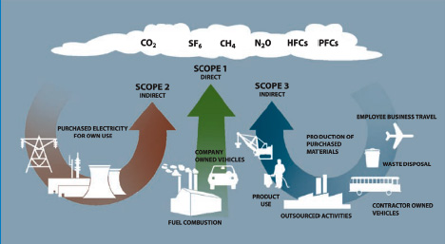.
Scope 1
Scope one emissions encompass all fuels that an entity would be responsible for burning or emitting as a direct result of their operations. These often involve heating systems, agricultural off-gassing, company-owned vehicle emissions, any livestock produced methane and fugitive refrigerant leaks. For UCSC, the majority of emissions fall under scope one because of their cogeneration plant which burns natural gas to generate heat and electricity. The campus fleet would include any personal vehicles the university owns as well as buses that the university fuels and operates. Vehicles owned by students or staff operated on campus would not be considered under scope one emissions.

Scope 2
Scope two emissions can encompass purchased electricity, steam or chilled water. The only infrastructure that exists at UCSC for scope two would be purchased electricity. The levels of scope two emissions fluctuates with the successful operation of the cogeneration plant. If the plant is being upgraded or repaired, the majority of emissions UCSC is responsible for become scope two emissions as heating and cooling of campus buildings must be powered by purchased electricity. With the new upgrade of the cogeneration plant being completed in the summer of 2015, the majority of HVAC emissions will be scope one emissions and scope two emissions should drop dramatically from the past two years of downtime during the cogen upgrade. Purchased electricity differs from scope one because UCSC is indirectly responsible for their emissions. It is true that the university provides the energy demand but it is under the local utility’s control which fuels are burned and at which efficiency they operate which makes this an indirect emission source.

Scope 3a
Scope 3 emissions are not typically divided into two categories, though they are divided here to simplify between indirect emissions that the university is funding (3a) and to those that are occurring indirectly from the universities existence, not as a result of university funding (3b). 3a emissions would include emissions from university funded air travel (employee or student), goods purchased (i.e. paper), solid waste (landfill/recycled/composted) emissions, purchased electricity distribution losses, and wastewater emissions.

Scope 3b
Scope 3b emissions would then be any indirect emissions not funded by the university. These emissions come from student/employee commuting and any air travel funded by students or employees (study abroad or relocation).

What is a Carbon tax?
There are many avenues to take in terms of reducing GHG emissions. This paper will focus on the many attributes and models of carbon taxes.

Revenue
A big question and administrative burden that comes with a carbon tax is what to do with the generated revenue of the tax. Revenue is generated by setting a price on emissions that come from various sources depending on the goal of the tax. Fossil fuels, electricity or carbon emissions are all potential targets under a carbon tax. Once the tax is assessed, the revenue is accumulated and redistributed under two general options, revenue-neutral and revenue-generating.

Neutral
A revenue-neutral tax relieves much of the administrative hurdles that comes with taxing. There are two versions of revenue neutrality. The first rendition is found in British Columbia where revenues collected through a tax on the burning of fossil fuels typically used in transportation and home heating such as gasoline, diesel and natural gas. The revenue is then redistributed system-wide to lower the income tax of all citizens with some of the funding additionally being targeted at helping vulnerable households and communities. This has a lighter administrative burden because there is very little decision making necessary for this to run smoothly. There is no need for a funding storage mechanism, no need to monitor the usage of funds or oversee the effective use of them.
The results of the BC carbon tax are encouraging. Compared to the rest of Canada, there has been a nearly 19% reduction in affected petroleum fuel consumption per capita, nearly a 9% reduction in greenhouse gas emissions from affected sources while having no significant impact on GDP per capita. This shows that a carbon tax can be effective at reducing fossil fuel use and greenhouse gas emissions yet not burdensome towards the productivity of the economy.
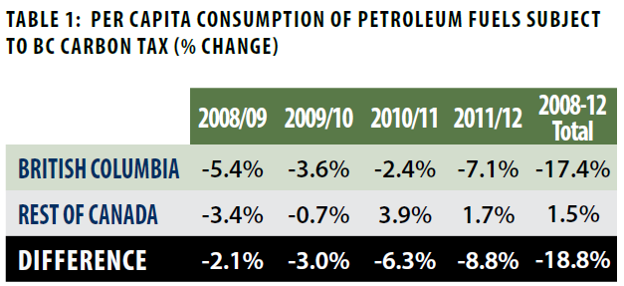
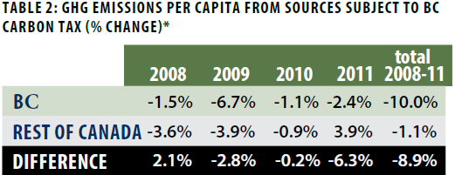
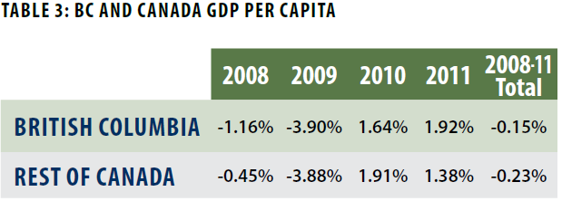
This focus on the lower class is because the lower class in a system-wide tax can be unfairly burdened with the tax as they often have to commute longer distances to work resulting in more gas being purchased and because they do not possess the capital to purchase expensive energy efficient vehicles or utilize alternative heat/energy sources that are less carbon intensive such as solar energy.
The second rendition of carbon neutrality is being planned at Yale University where the revenue generated from the carbon tax is shifted from departments performing poorly in their relative GHG emissions reductions to those that are performing well and reducing their emissions at a greater rate than the university as a whole. A hypothetical example follows.
The university sets a price for carbon at $10 per metric ton of carbon dioxide equivalent (MTCDE). The university as a whole reduces its emissions by 2% from the previous year. This 2% becomes the adjustment factor. Hypothetically, the Math department’s emissions remained constant at 100 MTCDE. Because they did not reduce their emissions by 2% down to 98 MTCDE, they must pay $10 for each ton they did not reduce which in this case is 2 MTCDE. They would then owe the system $20 ($10/MTCDE * 2 MTCDE). This $20 would then be distributed to another department which reduced their emissions greater than the whole university. By using this consistent adjustment factor based off the whole university, there is never a deficit or surplus of carbon revenue within the system.
Department | Base Emissions | Actual emissions | Adjustment Factor | Adjusted Base Emissions | Revenue
Math | 100 | 100 | 98% | 98 | - $20
Biology | 100 | 96 | 98% | 98 | - $20
University | 200 | 196 | 98% | 196 | $0

This relieves the tax of being responsible for delegating funds in any arbitrary way or holding them under any governing body, making it more advantageous administratively than a revenue generating fund. The algorithm is simple enough to implement on any scale within the university and also introduces a sense of competition between participating universities. One potential downside to this strategy is that there may be no effect if all departments perform the same in reductions, all would come out even. This could also hold if the departments and university increased emissions at the same rate, which would clearly suggest a failure in the effectiveness of the tax resulting in an increase in emissions. There is also the potential to be rewarding increased emissions if a department’s emissions are greater than their baseline but less than the university’s collective emissions.
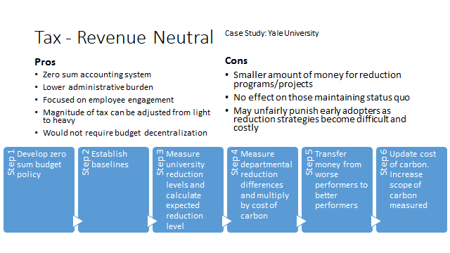
Revenue - Generating
A revenue-generating carbon tax would possess the unique characteristic of a central allocation fund or body that is responsible for collecting the funds and administering them for reasons other than keeping the tax revenue system in balance.
An advantage of a revenue generating carbon tax is that the centrally allocated funds can be used for various purposes where additional funding is needed. This can operate similar to seed funding for green revolving loan funds already present in higher education and in the Billion Dollar Green Challenge that are used to support energy efficiency projects that reduce carbon emissions. Supporting these projects have the added benefit of reducing the carbon tax base that the university would pay in following years because the initial projects’ carbon reduction benefits will benefit the university for many years in the future.
Microsoft has implemented a successful Carbon Fee model that charges organizational divisions directly based off of their emissions. They charge a small fee ($6-7) per MTCDE emitted by each department. This fee is embedded in their profit and loss statement each quarter. The funds collected are then deposited in a Carbon Fund. A group of decision makers are then responsible for which funds are used for supporting energy efficiency projects or purchasing carbon offsets to reach net carbon neutrality each financial quarter.
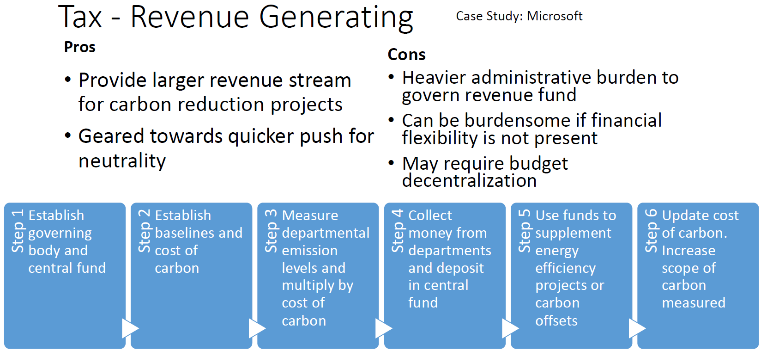

Microsoft Carbon Fee Model
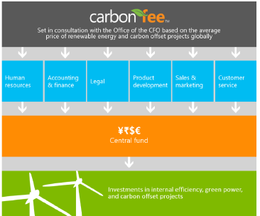

Type of Organization
The composition of a carbon accounting system will differ whether an organization is public, private or somewhere in between. They will each have different stakeholders to account for, different emissions sources and different financial mechanisms determining how a carbon tax will be administered, how it can affect their operations and who will experience the system change at a greater magnitude.

Public
A number of public entities have implemented carbon taxes in the past including the province of British Columbia, the nation of Ireland and the city of Boulder, Colorado. Ireland’s carbon tax began at $15 and has since undergone planned increases to $20/MTCDE, . Their tax is primarily targeted at gasoline and diesel use, largely affecting home heating. They also modified their vehicle registration tax to base off of the emissions ratings of each vehicle. They did not focus on large industry and power sectors as these entities are already affected by the European Union Emissions Trading System. Solid waste is also measured and taxed based on weight. The tax appears to be a success as there is a measured decline in fuel use, however given the unpredictability of the Irish economy in recent years it would be irresponsible to attribute these reductions solely to the influence of a carbon tax. It is too difficult to isolate the effects of the tax in this example.

Private
The Carbon Disclosure Project reports over 30 private organizations setting an internal price on carbon. Shell has set a price on carbon but not in the same way explained in the previous examples. They do not use the price to tax emissions within their organization. There is a growing understanding that those responsible for emissions will eventually have to address their role in climate change and how they will have to adapt to survive as a business. Big oil companies have begun collaborating on how to develop policy frameworks and a price of carbon to be used in their business models. Shell’s version of carbon pricing is based on a shadow price that takes into account some of the environmental externalities that are not traditionally factored into their new business ventures. The price helps them decide if the environmental cost of the project balances the financial benefit. These “shadow” prices also help prepare for cap and trade regulations that they may face in the future. For example, hypothetically there are two potential oil drilling sites with the same financial benefits. One of these sites will release a large store of methane gas when accessing the oil, while the other will not release methane. The shadow price puts a negative value to this embedded methane and provides a business case for prioritizing the oil site without the embedded methane, reducing net carbon emissions.

Education
Although there have been no schools who have practiced comprehensive internal carbon emission taxes, there have been promising examples of targeted mitigation efforts and pilot studies working towards implementation. Aside from Yale, Eastern Mennonite University has showed concerted efforts in implementing a pilot study in the coming year proposing a revenue generating model where the fees will be used to assisting reparation projects in areas of the world most affected and least able to adapt to climate change.

Goal
The overarching objective of these carbon taxes is to reduce emissions. However, the specific goals of each tax vary and can influence the type of model each follows.

Employee/Consumer Engagement
Carbon taxes can be very effective at increasing education and awareness about energy and GHG emissions. They can be effective because they affect individuals financially which everyone notices, whether they believe the climate change science or not. The current average cost of gasoline in California is $3.85. The carbon equivalent of one gallon of gasoline is 0.009 MTCDE. This miniscule statistic of carbon is not relatable without context. This context has been researched by the EPA to support their findings on a social cost of carbon near $37/MTCDE which accounts for all the environmental services and externalities overlooked in most typical business transactions such as purchasing a gallon of gasoline for a vehicle. Matching this cost of carbon with the carbon equivalent leaves us with an additional cost of (0.009MTCDE/gallon of gasoline * $37/MTCDE) $0.33 per gallon of gasoline. This is not an exorbitant surcharge though it is enough for the average consumer to contemplate their decision to drive a gasoline-powered vehicle or ride a bicycle. Revenue neutral models tend to work cost-effectively with employee engagement as administrative costs are lower and the financial burden is small enough to avoid the resultant push back from a large tax or fee while participants still feel the responsibility of reducing their emissions.

EE Investment
A common energy efficiency project funding mechanism in higher education is a green revolving loan fund. These are seed funds that provide loans for energy efficiency projects that pay back the principal using energy and utility savings. A carbon tax can be used to create this seed funding that may not be available otherwise. This has the positive feedback cycle of adding technological/energy efficient carbon reduction methods to the engagement/awareness already engendered in the revenue neutral models. The technological reductions lessen the burden on participants in following years with these additional projects resulting in less taxes being paid by participants.
If a carbon tax generates revenue for a fund, the next question is where does the money go? There also needs to be a department to hold the money and be responsible for its collection and distribution.

Carbon Offsets/Climate Disruption Mitigation
Aside from energy efficiency projects, tax revenues can be used towards green power purchases or carbon offset projects. These can contribute to an entity’s net carbon neutrality by offsetting scope 1 or 2 emissions with renewable energy purchased elsewhere. There are also more altruistic models where tax revenues can be donated to assist those groups most affected by the changes that climate disruption has wrought in recent years.

Alternative Methods
Alternative methods of financially influencing individual carbon emission behaviors exist from established cap and trade systems to carrot-on-a-stick models that incentivize energy savings rather than penalizing energy usage. To date there are 18 emissions trading systems (ETS) and 12 carbon taxation schemes implemented worldwide.

Cap and Trade or ETS
The idea behind a cap and trade model is to set a net emissions ceiling or cap. If an individual surpasses the emissions cap, they must pay penalties for their excess emissions. If an individual falls under the cap, they can sell their remaining allowed cap space to the excessive emitters.
The European Union (EU) has longest-running and largest international cap-and-trade system known as the EU Emissions Trading System (EU ETS). The EU ETS covers more than 11,000 power stations and industrial plants in 31 countries. These stations and plants are responsible for 45% of EU emissions. They have set a cap at 2.08 billion MTCO2e total system emissions. This means that the 11,000 entities must have a total emissions less than the cap or face heavy fines. Each entity is given a number of free emissions allowances towards the cap with the remaining being auctioned off. California has also introduced a similar cap-and-trade system through the California Air Resource Board (CARB) AB 32. AB 32 will affect all CA industries emitting more than 25,000 MTCO2e per year, approximately 250 industries including oil refineries, cement plants, electricity power plants and food processors. There are five universities and one medical center in the UC system that are capped by AB 32, particularly universities with on-campus cogeneration plants that create their own energy and a large amount of scope 1 emissions as a result.
Therefore, a cap and trade system differs from a carbon tax in two specific ways. An emissions trading market is created in the C&T system where a carbon tax penalizes everyone equally and the only way to escape the penalty is to reduce your own emissions. This runs close to purchasing offsets, yet the distinction remains. The C&T also differs in a positive emissions cap where a strict carbon tax would affect all emissions above net neutrality.

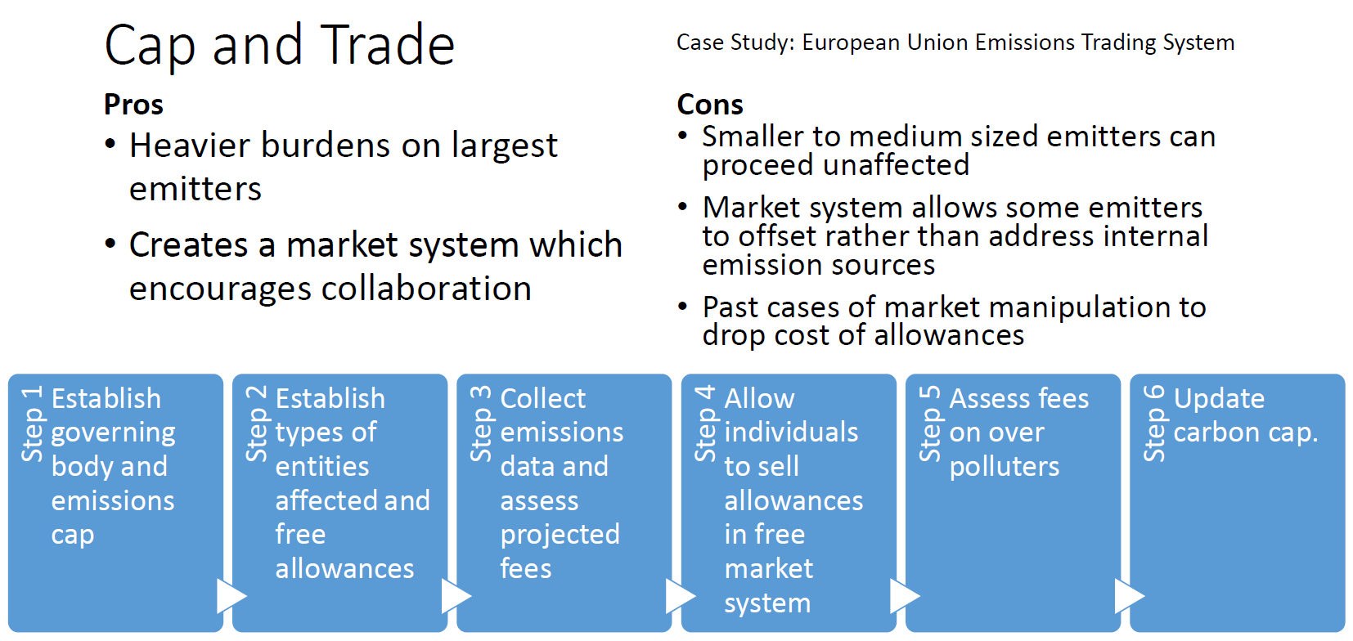

Map of Existing ETS and Carbon Taxes
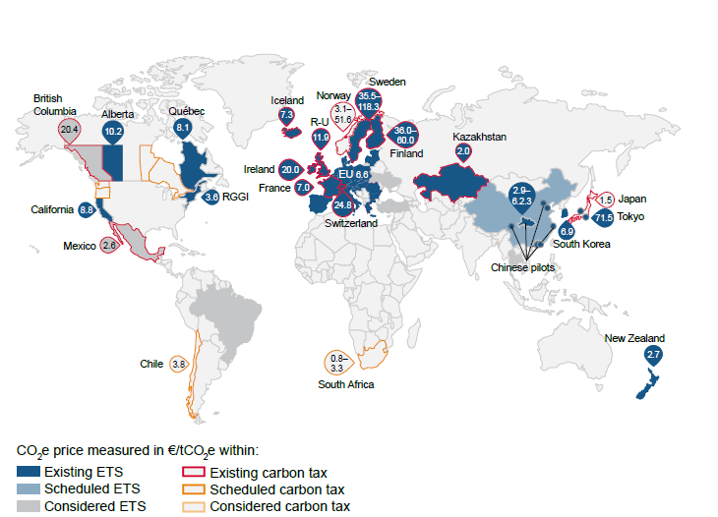

Carrot and Stick/Energy Savings Incentives
A carrot and stick model operates similarly to the revenue-neutral model. An individual receives benefits, or “carrots”, for reducing their emissions and penalties, or “the stick”, for exceeding their emissions. Reductions are based off of historical data baselines. This method works well for individuals of all sizes as it is based off of personal baselines, as opposed to the cap and trade method which is based on gross emissions. However, without enforcing the stick end of the model, there is less incentive to change.
The carrot and stick model becomes a savings incentive when the stick is removed from the equation. This is currently implemented at UC Berkeley in their Energy Incentive Program (EIP) where operating units receive financial benefit for reducing electricity use compared to their 2010- 2011 baseline. Operating units (OU) then use these rewards to fund energy efficiency projects to continue reducing emissions. The model began as just a savings incentive initiative but has since implemented the stick portion within their model where OU’s would be charged extra for electricity use over their baseline. However, since no operating unit has failed to reduce their energy use to date, no penalties have been assessed. However, the funding for this model is not revenue neutral. The funds for the incentives come from utility savings that facilities realizes from the utility provider with the reduced electricity use. The incentive is then passed on to operating units to be used for energy reduction projects.
A clear difference between the Yale and Berkeley models is that the Yale model appears to target all scope 1 and 2 emissions while the Berkeley model targets electricity consumption.
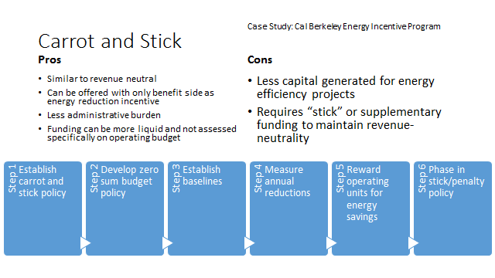

Snapshot of Carbon Accounting Systems,,,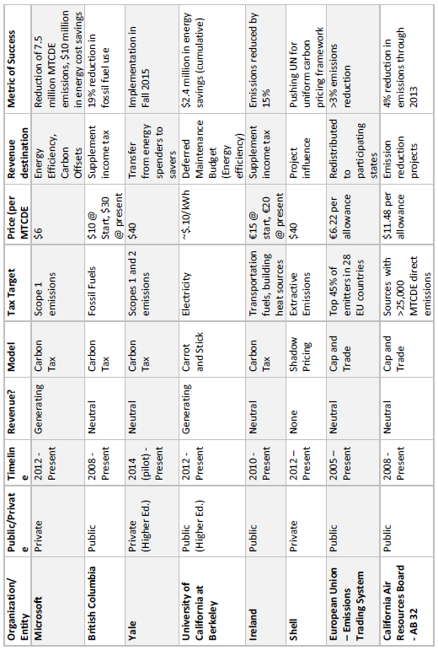
Is a Carbon Tax the Most Effective Vehicle towards Neutrality at a Public University?
Strategies for reaching carbon neutrality range from technical to behavioral and some may be easier than others to implement. Green revolving loan funds, employee engagement campaigns, renewable energy projects, carbon offsets and green power purchasing are among the many different strategies used to reach neutrality so it is important to analyze if a carbon tax is effective or not and whether it is worth the time and money necessary to break down the administrative barriers that pose challenges. Leaders in higher education at UC Berkeley and Stanford University have advocated for carbon tax situations in the past despite these challenges,.
If the UC must simply reach the carbon neutrality goal at 2025, it is possible to spend money on carbon offsets as a solution. Carbon offsets can cost anywhere from $2-30 per MTCDE. Below is a table showing the projected emissions at UCSC through 2025. A 10% reduction per year starting in 2016 shows the potential amount of emissions reduction UCSC would have to achieve to reach neutrality by 2025. The cost to purchase offsets to hit these reduction goals is also given using the general lowest price of offsets on the market.

UCSC Costs for Neutrality Through Offsets
Year | UCSC Scope 1 Carbon Emissions | Offset Price / MTCDE | Cost for Neutrality | Increasing Reduction % | Amount to reduce | Emissions after offset reduction | Cost for reduction
2016 | 29107.38 | $2.00 | $ 58,214.77 | 10% | 2910.74 | 26196.65 | $5,821.48
2017 | 29277.67 | $2.00 | $ 58,555.34 | 20% | 5855.53 | 23422.14 | $11,711.07
2018 | 29243.79 | $2.00 | $ 58,487.59 | 30% | 8773.14 | 20470.66 | $17,546.28
2019 | 29249.35 | $2.00 | $ 58,498.70 | 40% | 11699.74 | 17549.61 | $23,399.48
2020 | 29369.78 | $2.00 | $ 58,739.55 | 50% | 14684.89 | 14684.89 | $29,369.78
2021 | 29398.53 | $2.00 | $ 58,797.07 | 60% | 17639.12 | 11759.41 | $35,278.24
2022 | 29418.14 | $2.00 | $ 58,836.28 | 70% | 20592.70 | 8825.44 | $41,185.39
2023 | 29485.28 | $2.00 | $ 58,970.56 | 80% | 23588.22 | 5897.06 | $47,176.45
2024 | 29485.28 | $2.00 | $ 58,970.56 | 90% | 26536.75 | 2948.53 | $53,073.51
2025 | 29485.28 | $2.00 | $ 58,970.56 | 100% | 29485.28 | 0.00 | $58,970.56

The price of offsets or renewable energy certificates (RECs) depends on many contributing factors including when the energy was produced, where the offset is located, how the offset is certified and the source type of the offset. These offsets or RECs are typically classified into “buckets” based on these contributing factors where bucket 1 RECs tend to be the more expensive option, nearby geographically and of a particular value to a community. Bucket 3 RECs are less expensive and can be purchased from anywhere in the US where they can be produced for less money. Using bucket 3 RECs or offsets to achieve neutrality would cost the university upwards of $58,000 each year which could grow very costly if direct emissions are not addressed through reduction projects. It should also be noted that the university prefers to purchase bucket 1 or 2 offsets which can be quite a bit more expensive around $20-30 which would raise the cost of neutrality closer to $580,000 per year. Considering there is still ten years before the neutrality goal, it is very likely that UCSC will see a decrease in direct emissions and require less offsets to be purchased to reach neutrality before then. These offsets should be seen as a supplement not a solution but they are also something that could be funded by revenue generated in a carbon accounting tax. Microsoft showed success in being able to utilize RECs to reach neutrality but given the UC extended timeline, the purchasing of RECs should be considered nearer to 2025.

Who Makes the Decisions on Projects Moving towards Carbon Neutrality?
Which departments or individuals act as decision makers within each university? How much influence do they have? The diversity of stakeholders involved in taxing an entire university is great so it is essential that the carbon accounting system is engaging those with the most power in influencing carbon reduction strategies. Facilities Department, Sustainability Office, Budget and Financing, and the C Suite would all be expected to hold a substantial amount of power in how the push towards carbon neutrality progresses. An effective carbon tax must engage each of these stakeholders.

Will a Carbon Tax Affect the Correct Decision Makers?
The effect of a carbon tax must include influencing and engaging those responsible for energy consumption and carbon emissions. If a tax is directed at students and faculty yet not felt by those responsible for making the decisions a university makes to reduce the carbon emissions and subsequent tax penalties would be met with resistance and predictably less success.
Ideally a carbon accounting system would account for all campus members. This may not be the most easily implemented scenario as buildings can be multi-use or house multiple departments which causes issues with who is accountable for which proportions of energy. This makes the system easier to implement by metering and monitoring the most distinguishable departments or operating units and exclude buildings or departments that do not possess the sub-metering granularity to record precise and accurate emissions data. Including residence halls and on-campus housing has the added benefit of directly addressing students and the opportunity to gain their support in addressing carbon emissions through a carbon accounting system. Currently, students indirectly pay for their utility costs through their bundled residence hall room price based off of utility usage from the previous year. Updating the current system to provide monthly energy consumption and energy cost data to current residents allows students to become more active and engaged in reducing carbon emissions in their personal living situations with the potential to reduce costs with an energy reduction incentive program.
Some campus departments and facilities may also be funded through state or federal research grants. The utility costs for operating research facilities are embedded within the overhead the university requires in research grant approval. The utility budget is not earmarked or distinguishable from the remaining grant funding. This additional complication poses considerable challenges in determining which types of funding can be transferred/altered/managed by a carbon tax. Grants can be government or taxpayer funded as well bringing the budget under deeper scrutiny from others that may not have the same goals as the university or researchers using the funding. Navigating these financial hurdles may require restructuring traditional grant policy unless a simpler model is engineered or discovered that bypasses this grant structure. Grant funding could be excluded from the carbon tax, though this would limit its effectiveness as research labs that use these grants are often large energy consumers on a campus.

Case Study: UCSC
The University of California at Santa Cruz is being used as a case study, not because they are the most likely to implement a carbon accounting system but because they are the most accessible to research and interview in the given circumstance.

Goal of Tax
The UC objective of 2025 carbon neutrality is ambitious and will require the collaboration of many stakeholders and policy decisions. It is perceived as ambitious because only three higher education institutions have reached carbon neutrality as of July 2013, Colby University, Green Mountain College, College of the Atlantic and University of Minnesota at Morris, all of which hold an enrollment of at most 1800. UC Santa Cruz is nearly ten times the size so their emissions are predictably quite a bit larger than those achieving neutrality. The timeline of 2025, giving the ten UCs ten years to reach neutrality, is quite expeditious compared to other neutrality goals set in higher education. Of the 538 universities with carbon neutrality goals, 114 (22%) are set to achieve neutrality within the same time frame or sooner.

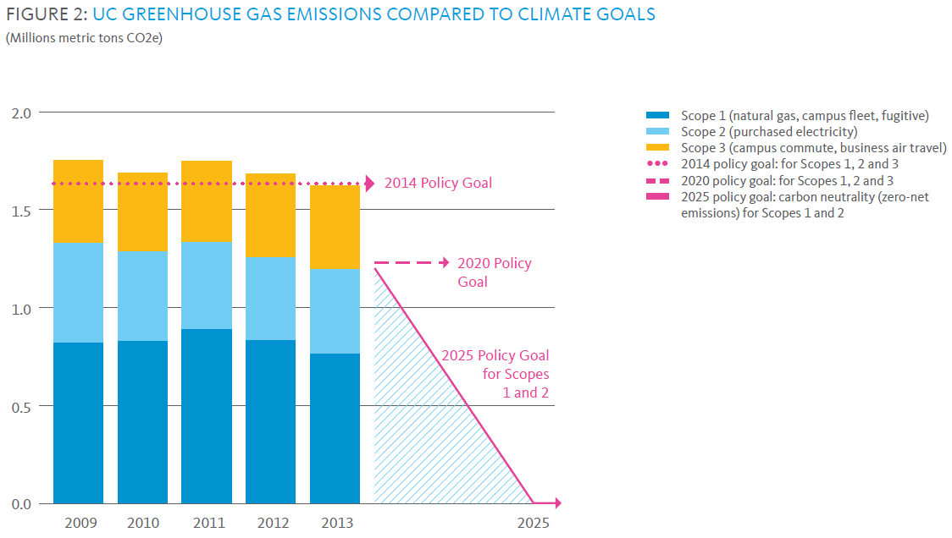
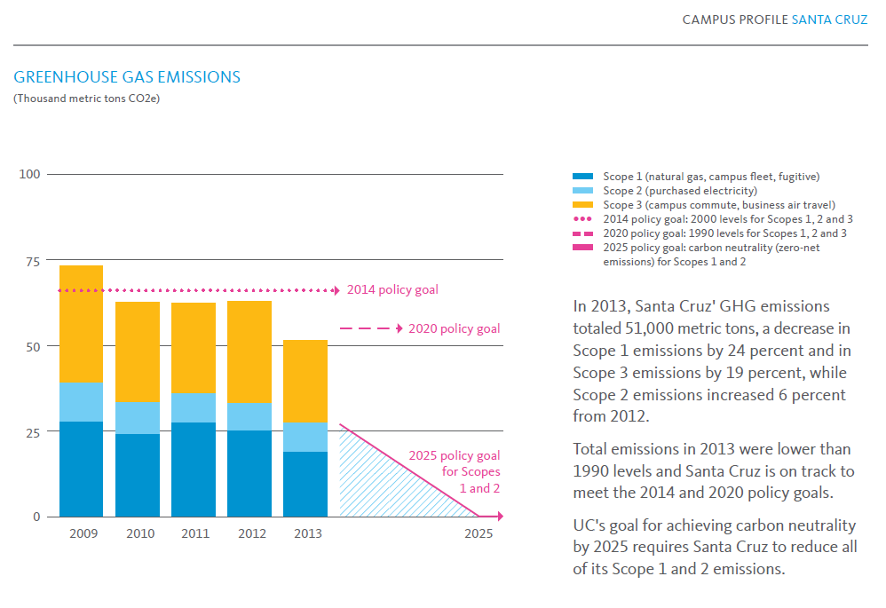
Given the complexities of a carbon revenue or a carbon generating tax, it may be best for the UC system to pursue a revenue neutral carbon tax. It will take many stakeholders, policies and investment decisions to reach neutrality and a revenue-neutral carbon tax will provide just enough push to plant the seed of change in each of these areas. The tax will already have to be rather complex as a public university has a multitude of affected moving parts. That said, each university within the UC system is unique and diverse and one overarching tax system will either be too complex to understand, too broad to be effective or too imbalanced to accommodate for these diversities.
The goal of the carbon tax should not be to solve the problem outright as the revenue-generating tax at Microsoft accomplished. Microsoft believes that 10% of emission reductions were a result solely by disseminating consumption and emission information to individual departments. Opower, a cloud-based software company, claims a 3.5% reduction in consumption when utility customers use its software for information awareness and behavioral change. The carbon tax is just another stepping stone of engagement and education used to facilitate the change that the UC system hopes to exemplify in the public education sector.
Given the options stated above, it is important for the university establishing a carbon fee or accounting system to define whether the carbon tax should feed into energy efficiency projects. As the carbon tax becomes more geared towards funding energy efficiency projects, the tax also becomes more complex and finds more bureaucratic barriers in the public or private higher education systems. Prioritizing the goals of the tax allows us to focus our energies on answering the more relevant questions within each distinct carbon reduction system.

What/Who to Tax
If the concern of the carbon neutrality initiative is to focus on scopes one and two, then students should not necessarily be the only priority in considering who to affect and influence with carbon accounting. Many of the emissions associated with students are not accountable through scopes one and two. Much of their emissions fall under scope 3, which in this case is not the focus of the UC 2025 neutrality pledge. On campus student housing is a substantial source of scope one and two emissions, but it is a necessity to focus the system on engaging staff and faculty behaviors as they are equally responsible for on campus emissions.
The majority of scope one and two emissions can be directly associated with actions taken by staff and faculty in their activities on campus. If we expect to reduce these emissions sources, it is essential that we have an impact on these two parties and engage them with understandable information and achievable reduction strategies to accompany the carbon accounting system. The more essential decision makers mentioned earlier fall into these parties, making it a necessity that these are the individuals who receive the advantages or disadvantages of carbon accounting system would introduce.

Obstacles
The University of California is a public institution which presents its own set of obstacles and challenges compared to the private setting found at Microsoft or Yale University.

Who Pays Energy Bills
A major complication, whether at public and private universities, is where funding comes from for energy budgets and how these budgets are paid within individual buildings. Public universities like UCSC have different compositions of building funding structures including state-funded, auxiliary and self-sufficient buildings. State-funded budgets would be untouchable in a carbon accounting system model with the existing centralized budget. Auxiliary buildings are partially funded by other departmental budgets. Self-sufficient buildings raise their own funding through rent (residence halls) or sales (cafeterias). Each type has their own distinct method in paying energy bills. On any given UC campus, each type of building funding would need to be addressed when determining which is the most effective way to impress the magnitude of emissions reductions.
Public university budgets are largely centralized, meaning departments are not responsible for or aware of certain operational costs associated with their facilities, like the energy budget. This posits the challenge in informing building inhabitants of the energy they are using based off of their utility bills. They do not see their utility bills nor manage the funds used to pay them. Establishing a tax on them within this structure would not only unfairly burden the centralized budget paying for them (often the facilities departments) with additional fees they have no control over, it would go unnoticed as it would not affect the departments budgets individually. Private settings may have decentralized budgets where individual departments are responsible for their energy bills and are aware of their consumption because of this, though private universities still have the same issues as public universities as departments can be university funded and still unaware of their energy budgets.
Decentralizing the budgets at UCSC would be a very time-consuming process which would put ample strain on the budgeting and finance department to implement this policy change. The timeline on a policy change of this size would be on the scale of years involving developing the value and business case for changing a system that has worked for decades and gaining support from every corner of the university. It would require perhaps more effort and bureaucratic lobbying and shuffling than the initial carbon tax. It may be more appropriate to follow the UC Berkeley model of keeping the centralized budget and only disseminating consumption information, rather than costs, to departments and leaving the current funding mechanisms intact.

Division of Buildings/Submetering
A similar obstacle found at both public and private universities is the mixing of departments within buildings. Any given building in higher education can hold Professors’ offices from separately funded departments, classrooms used by any/all departments and energy intensive science labs used only by one department. This division becomes a central challenge with a carbon tax even in decentralized settings as budgets are typically paid by departments, not by building inhabitants. Desegregating energy usage and proportioning costs can become complicated very fast in any setting. Currently used models tend to make proportional calculation assumptions on square footage within a mixed building to allocate emission responsibilities to different departments or OUs based off of lab or office size.
For example, if a small building has 5 offices with two belonging to the engineering department and 3 belonging to the humanities department, we would make the assumption that 60% (⅗ offices) of the energy emissions are accountable to the engineering department. This would leave the remaining 40% of emissions to be allocated to the humanities department. Another option is to keep the tax as a pilot on departments where the intermixing of departments and complexities is not present until the submetering is granular enough to overcome this challenge. This is a simple example and real world scenarios are undoubtedly more complicated in these multi-use buildings.

Where Does the Money Come From?
As mentioned in the above paragraphs, the root of budget funding can be complex. Certain unique situations in publicly funded departments pose their own problems. Science labs funded by government grants do not typically account for energy budgets and the social cost of carbon within their planning process currently. This funding is typically very strict in the first place so any additional taxes or fees on this grant money is sure to elicit push back.
As some buildings obtain funding through state funding, if a tax is assessed where money is taken from partially state funded departments then clear accounting pathways would be necessary to ensure state funds are untouched by the carbon tax to avoid additional political resistance.
Departmental budget expenses are broken down into academic salaries, staff salaries, general assistance, equipment & special outlays, retirement & employee benefits, and recharge income (if applicable). These expense budgets are sourced through a combination of State of California, tuition & fees, extramural support, auxiliary enterprises and other sources of funding. Some of these areas are restricted and could not be subject to a carbon tax. Some only apply to certain departments. Some would be inappropriate in terms of supporting energy budgets or carbon accounting systems. The balancing act of finding the correct source and partitioning from or to the correct expense budget is delicate and places strain on the financing and budget department, requiring their full support and input on this process.

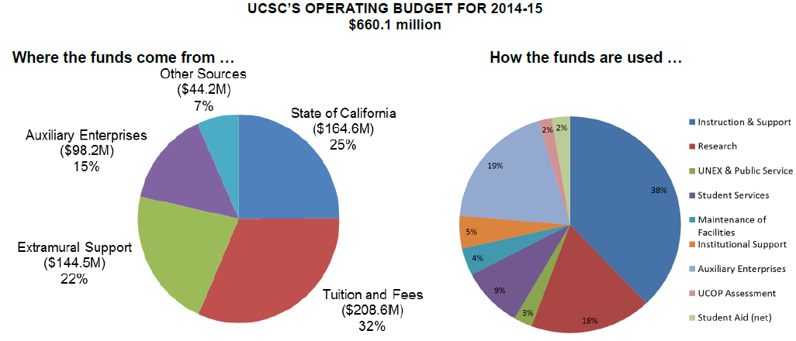

UCSC implemented a similar idea to a revenue neutral carbon tax to drive down worker’s compensation costs throughout the university. A revenue neutral system was used where departments received benefits for reducing worker’s comp usage and penalties for using over the average number of allowances. Funds were balanced between departments’ employee benefits budget. The system had an implementation process of approximately eight years which resulted in substantial decreases since its initiation (nearly 80% reduction in extra costs). This is a good example of how budget balancing can be used to reduce costs and evidence that finding the correct balance of funding sources and budget expense locations is not out of reach in the current centralized financing model but also that these complex revenue manipulation systems require many years of trial and error to become effective.
The transportation department is accountable for a portion of scope 1 emissions, the campus fleet. The current funding for more sustainable transportation options and fuel efficiency projects comes predominantly from selling parking permits. If the UC goal is to reduce these emissions, that would entail discouraging driving and parking on campus by students, staff and faculty. Therefore, if the transportation department is successful in reducing carbon emissions by promoting sustainable transportation options, they are effectively reducing their own budget. This is a disincentive for improvement that will need to be re-examined if campus fleet emissions are to be reduced with other emission sources. A carrot and stick model program could potentially offer this department some incentive to reduce fuel use and encourage innovation.

Universal Support
Whether in private settings, medical schools, public provinces, or any number of demographics, environmental concerns are not always a priority, especially when it comes to money matters. Universities act as miniature versions of each of these situations and getting a doctor to sacrifice air changes for the sake of saving money in an HVAC efficiency policy change is not a priority when it comes to hospital settings and affecting inhabitants’ health. Despite a neutrality goal set by the president, it is hard to believe that all within the UC system are 100% behind these ambitious goals.
It may take months or years to gain support from all parties involved in implementing a new carbon accounting system. This is highly dependent on how intrusive the system becomes and how heavy the financial goals and prices are set. Given its ubiquitous nature, it may be wise to approach both student leaders and the C-suite for champions that can rally additional support and expedite the political process. Below is a list of stakeholders who would need to be on board, this is not exhaustive as this is still an exploratory process and as such, the process should be quick to adapt to unforeseen stakeholders and their requests.

Stakeholder Map
Stakeholder | Why do they matter | Influence/ Interest High/Med-ium/Low | How best to contact? Inform? Influence? | Potential Point of Contact
University of California Office of the President | President set neutrality goal; oversee UCSC operation | H/H | Climate Working Group | UCOP Sustainability Director
University of California at Santa Cruz | Funding half of the position; face AB 32 taxation; affect all students, faculty, staff; responsible for implementation | H/H | Committee on Sustainability and Stewardship | UCSC Climate Action Manager/Director of Sustainability
UCSC Office of Sustainability | Focus on all related issues; potential managers of system | H/H | Office Meetings/e-mail blast | UCSC Climate Action Manager/Director of Sustainability
Global Climate Leadership Council | Responsible future guidance, implementation, support | H/H |  | GCLC Climate Working Group, UCOP Directof of Sustainability
Environmental Defense Fund | Representative on GCLC | L/M |  | Director of California Climate Initiative
Student body | Generally interested in climate change, could affect residence halls financially | M/H |  | UCOP CNI Fellows
California | Would like to see all GHG reduced | L/L
Taxpayers | Could have a stake financially if money is coming from state funds/taxpayers | L/H
Facilities Staff | Responsible for submetering, will reap financial benefits of reduced consumption, would like more funding for EE projects, would also benefit from increased employee awareness | H/M |  | Energy Manager/Associate Director, Physical Plant/ Energy Analyst
Transportation | Responsible for campus fleet; could benefit if incentives are set | H/H |  | Director of Transportation and Parking Services
Higher Education | Only one pilot out now; field is open to set an example, especiallly in public setting | L/M |  | AASHE
Staff & Faculty | Financially affected, may receive benefits and penalties of accounting system; would benefit from greater emissions transparency | H/H
Financing Department | Makes policy decisions on a carbon tax project; create blueprint for funding mechanism | H/H |  | Director of Budget and Resource Management
UC System | Would all benefit from any system wide reduction policy | H/H |  | UCOP Director of Sustainability
C-suite | Need approval from all C-suite; would benefit from a champion, possible startup funding | H/M |  | UCSC Chancellor

Dashboards
Granular energy dashboards are not unheard of in higher education, however they are far from universal. These dashboards relay in real-time the amount of energy being consumed by a given building,. These become essential tools in influencing inhabitant behavior change as most individuals do not have a definitive grasp on their consumption/GHG emissions at any given time. These become beneficial in additional ways with a carbon tax. Emission reductions within each department become visual and inspire continued education and innovation. The carbon accounting process becomes simplified as data is more readily available, reducing administrative costs of a potential carbon tax. Friendly competition between departments becomes much easier to implement and drive further change. Without simple visual representation, those currently unaware of their daily emissions, remain in the dark and are still not faced with the impact they are having on GHG emissions.

Setting a Price
Setting the cost of carbon will be a challenge for any governing body. The EPA published a report with a matrix of potential social costs of carbon (scc) based off of various discount rates and what their collective working group valued as the cost of carbon to the environment. Their scc ranges from $5 - $134 with an average price near $37, which is broad to say the least. UCSC could choose to base their carbon price off of these scc projections or off of projections to purchase carbon net neutrality as Microsoft has done in their carbon fee. The cost of carbon at the university should value itself off of more than just the environmental costs. The cost should reflect the goals of the tax, be appropriate to those being affected and yet be adaptable to change. Ideally, the price should be set low enough not to be a heavy burden on departments yet high enough to have an impact and not be swept into their embedded budgets as energy bills have been subjected to in the past.

Existing and Past Carbon Prices,
Organization | year | price ($)
Australia | 2012-2013 | 23.00
Australia | 2013-2014 | 24.15
Cenous Energy | 2014 | 15-65
TD Bank | 2014 | 10.00
Teck Resources | 2014 | 30-60
TransAlta Corporation | 2014 | 15-23
Disney | 2014 | 10.0-20.0
Mars | 2014 | 20-30
ConocoPhillips | 2014 | 8.0-46
Encana Corporation | 2014 | 10.0-80
Exxon | 2014 | 60-80
Devon Energy | 2014 | 15.00
Google | 2014 | 14.00
Microsoft | 2014 | 6.0-7
Ameren | 2014 | 30.00
Xcel Energy | 2014 | 20.00
British Sky Broadcasting | 2014 | 19.44
BP | 2014 | 40.00
Cairn Energy | 2014 | 30.00
Marshalls | 2014 | 19.44
National Grid | 2014 | 89.10
Pennon Group | 2014 | 84.24-324
AzkoNobel | 2014 | 64.50
Royal Dutch Shell | 2014 | 40.00
Westpac Banking | 2014 | 10.00
Other Campuses
As each university is very unique within the UC system, a one size fits all model for a carbon tax is highly unlikely to be the most effective manner of communicating this carbon reduction strategy. Some universities are not affected by AB 32 and may need more incentive to pursue reductions. Some universities are much larger than others and some have different electrical grid fuel sources, all affecting their base emissions. This changes the goals of the tax and what would make it a successful reduction strategy. Climate variations also face each university with unique building conditioning challenges.

Sub Metering Needs
An essential element to taxing a university’s energy consumption at any level lower than as a whole is sustaining adequate sub-metering needs and the data collection involved. Each university in the UC system has different sub-metering capabilities currently so a carbon tax would initially have to adapt to these capabilities as universities work towards more granular data collection and comprehensive sub-metering.

Building Divisions
Additionally, as evidenced by the collaborative building compositions on the UCSC campus, this holds throughout the UC system where the inhabitants and uses of each building take a multitude of forms and each would require their own detailed guidelines for a carbon tax.

Benefits
The benefits are just as numerous as the obstacles which makes this topic inspire so much academic debate.

Reduce GHG Emissions
The most obvious and important goal of this accounting process is to reduce greenhouse gas emissions and begin the process of reversing climate disruption. The combined emissions of the UC system make it one of the larger organizations emitting carbon in California. Climate change is an issue with tremendous challenges and potential repercussions that must be addressed. A single university making large reductions is still a minute drop in the bucket, but being responsible for one’s actions and setting an example can lead to systemic changes.

Set an Example for the UC system and Higher Education
If a carbon accounting tax is established at UCSC or any one of the UCs, it will set an example for the remaining universities to achieve and establish a working pilot to expedite implementation throughout the system. Additionally, along with Yale and other universities pursuing this carbon accounting model, UC will be an example for all of higher education, especially public universities, that this is an achievable and worthwhile project to undertake.

Reach President’s Goal
President Napolitano’s goal for carbon neutrality by 2025 is lofty and ambitious, yet not out of the realm of possibility. Each university doing their part to reach this goal will not only likely gain favor from the President, they will also bolster the UC reputation as a leader in higher education and reinforce the UC mission and priorities towards their commitments.

Save Money
The goal of reducing carbon emissions is the main focus. However, each university must pay utilities for electricity and natural gas that contribute to emissions and each reduction in consumption of these utilities translates to a reduction in spending. History has shown us that utility prices can fluctuate rapidly so reducing our dependence on these volatile price structures reduces our spending and risk for increased spending in the future.

Reduce Penalties from AB 32
The university currently has purchased allowances for scope 1 carbon emissions through 2020 however, given that AB 32 remains in place past 2020, it would benefit the university to reduce emissions and avoid having to buy more allowances in the future. There is also potential for the current AB 32 cap of 25,000 MTCDE to ramp down, as is the case with the EU ETS system, which would force the university to purchase further allowances if they have not pursued enough carbon reduction options.

Competitiveness for Attracting New Students
Being an example in climate change mitigation has the added potential of being more attractive to a more sustainably-minded younger generation. Climate change is one of the most pressing issues in American society and a university exemplifying sustainable values adds to the attractiveness to the university selection process. Having information on a university’s commitment to environmental issues was at least “somewhat” influential for 60% of incoming students according to a Princeton Review survey of 10,000 students and parents.

Provide Capital for EE projects
Providing seed funding for additional energy efficiency and carbon reduction projects is a potential benefit highly dependent on the funding structure and tax model used. Some models are better suited than others for this opportunity, yet the potential remains. Any additional funding will not only speed up the carbon reduction process a university is pursuing but lessen the burden of a carbon tax on the university in the future.
It is advised in the Billion Dollar Green Challenge that the ideal starting point for seed funding at UCSC would be approximately $1,000,000 to fund viable projects that could return energy savings into the project planning budget. If a revenue generating model is chosen, it may be best to set the price of carbon at a level to meet this funding recommendation. Divided between the 6 academic divisions, this would equate to approximately 0.75% of the academic budget within each division collectively. This would appear to be small enough to be manageable yet still substantial enough to be noticeable within the financial planning of each division.

UCSC Academic Divisional Budget
UCSC Academic Divisions | Total Budget | 0.75% of Budget
Arts | $ 13,542,522.00 | $ 101,568.92
Engineering | $ 18,762,693.00 | $ 140,720.20
Humanities | $ 19,903,202.00 | $ 149,274.02
Library | $ 8,308,533.00 | $ 62,314.00
Physical and Biological Sciences | $ 34,284,978.00 | $ 257,137.34
Social Sciences | $ 26,756,220.00 | $ 200,671.65
University Extension | $ 9,776,504.00 | $ 73,323.78
Total | $ 131,334,652.00 | $ 985,009.89

Future Recommendations

Complementary Concurrent Projects
There are a number of projects that UCSC is currently working on that would mutually benefit with a carbon accounting system. They offer additional methods of addressing the carbon neutrality goal and simultaneously would improve the effectiveness of a carbon tax or accounting system.

Green Office Certification
Once affected by carbon accounting, it can be expected that staff and faculty would begin to seek out additional ways they can reduce energy. The Sustainability Office at UCSC already has a Green Office Certification program that assists employees in reducing their office energy consumption. The carbon accounting system could lead to greater participation in the GOC and further employee engagement on top of energy consumption awareness.

EnergyCAP
For any of these carbon accounting models to be effective and reliable, the measurement and verification of carbon/energy consumption needs to improve. EnergyCAP is the system used by the UC to track and display energy data. Greater emphasis must be placed on mastering this system and using its many options to the university’s advantage. EnergyCAP can provide the utility report data that should be disseminated to users when accounting for carbon emissions. There are many energy management software programs available, but given EnergyCAP is the one already in place, it would make sense to stick with this program and improve its usage.
Improving the EnergyCAP software usage requires more labor and in turn more funding. The Yale model uses a small percentage of carbon tax revenue to fund administrative costs. This could be done similarly at UCSC to improve its EnergyCAP capabilities and strengthen it carbon accounting and transparency. The type of information and how it is represented to most effectively engage participants should be further researched. Carbon emissions can be symbolized in many ways from MTCDE, to personal carbon footprints to equivalent cars being taken off the road. All of these metrics appeal to different personality types and have their own connotations. Information distribution, transparency and relatability should be a top priority moving forward with or without a new carbon accounting system.

UCSC Carbon Fund
The student funded, carbon fund can work concurrently with any carbon accounting model. The carbon fund could be used as a storing mechanism in any revenue generating scenario as the money could then be easily used for energy efficiency projects that may not receive enough funding through the current student fee model. The sustainability project clearinghouse is also a place where staff, faculty or students could propose projects that would reduce their department’s carbon emissions and the resulting carbon fee.

Green Revolving Loan Fund/Billion Dollar Green Challenge
Given the complexities of funding structures at a public university partially funded by state taxpayers, the greater chance of success for carbon accounting may come with keeping carbon prices low, budgetary impacts just big enough to be noticeable and to not place the burden of funding energy efficiency and renewable energy projects with carbon accounting generated funds. There are currently proposals being researched for green revolving loan funds (GRLF) reflecting the model supported in the Billion Dollar Green Challenge. A green revolving loan fund is a source of seed funding that is loaned out to complete energy efficiency projects that is paid back using the energy savings resulting after project completion. The Billion Dollar Green Challenge is a nonprofit effort that supports implementing more GRLFs throughout higher education and nonprofits. Any carbon accounting model could potentially feed revenue streams into a GRLF that would be responsible for capital intensive energy efficient projects.
This keeps the carbon accounting model much similar and relieves much of the administrative burden that would come with project portfolio management, financial management, project planning and measurement and verification.
UCSC currently is able to acquire low-interest funding through its strategic energy partnership with the local utility. This allows any carbon accounting system to focus solely on employee engagement rather than needing to address the funding challenges that come with capital intensive energy efficiency projects. This allows the setting of a carbon price at a level that is only high enough to draw attention to energy usage rather than at a level to support multi-million dollar energy reduction projects. This will not be the case at every university but allows UCSC to pursue simpler options when choosing a system that is most effective and appropriate.

Include Scope 3 Emissions
The current UC neutrality goals do not account scope 3 emissions. However, this should not be an excuse to ignore them. Whether indirect or direct, the university is responsible for emissions that are contributing to global warming. Current scope 3 emissions goals are less strict as the challenge is greater and harder to solve.
The UCSC Transportation department has been pursuing sustainable transportation strategies for over twenty years with efforts focused on all emission sources. Much of their efforts are focused on reducing student/staff commuting which is classified as a scope 3 emission. Their successful innovations include vanpools which reduce student commuting emissions by a factor of 8 at times. However, the vanpool is funded by the university so these emissions then become scope 1 emissions. From a holistic perspective, the vanpool is a much greater improvement for the community. Traffic is reduced by replacing 8 single occupant vehicles commuting to campus with one van. Emissions are in turn reduced on the same scale. However, in a neutrality goal only accounting for scopes 1 and 2, this is a regression as the emissions from the van become accountable to the university. This is another disincentive the transportation department faces under the current system. The same logic follows for university shuttles and bike shuttles. These options promote alternative transportation and reduce overall emissions but add to the UC’s scope 1 emissions.
This example brings up the potential future complication of leaking scope 1 emissions into scope 3 emissions to avoid a carbon tax. Scope 3 emissions covers the emissions associated with purchased goods and without the inclusion of scope 3, staff and faculty are not faced with the emissions associated with their work purchases. A research project may choose to outsource to an off-campus building or operation to avoid paying scope 1 fees (off-campus buildings used for research would be a scope 3 emission source).
Along with commuting emissions, employee air travel accounts for a substantial amount of emissions in the UCSC GHG inventory. Pilot studies are being implemented or proposed at Portland State University, Arizona State University, University of Oregon and UCLA to establish a carbon offset price for employee travel,. These operate similar to an internal carbon price, only targeting one source of emissions rather than the two scopes focused on here. It is a popular focus for carbon pricing because of the straight forward accounting process and the magnitude of emissions associated with air travel.
There are additional scope 3 emissions sources to account for in the GHG inventory process. Each contributes collectively to climate disruption and needs to be addressed. Scope three emissions are complicated and their emission keeps the accounting system simple. However, this should be a temporary omission and will need to be addressed in the future.

Establish Carbon Accounting Management Position
Regardless of the model used, the administrative burden would be too great for one individual already employed at the university. Monitoring accurate data collection, disseminating information, collaborating with stakeholders and coordinating with carbon reduction projects to reinforce and improve the carbon tax model will be essential to its effectiveness.
This position could be located in either the Facilities Department or Sustainability Office. An important aspect of this position is to work together with Facilities and Sustainability staff to coordinate ideas and manage data collection and, eventually, dissemination of information across campus. The position should be well-trained with the EnergyCAP software as it will be a key component in data collection. Seeing that EnergyCAP is still in its infant stages at UCSC, it would be appropriate to establish this position to accelerate the acceptance and to better understand its potential to assist in the carbon accounting process. Given its collaborative nature, the position should report to both the Energy Manager in Facilities Services and the Climate Action Manager in the Sustainability Office.
Under any carbon accounting revenue model, there should be a 5% overhead taken out of the tax revenue to supplement this management position and the associated administrative costs. This would make the position self-sustaining following the first year where some startup funding will be necessary.

Short-term goals
6-12 months - Assess current GHG accounting at an operating unit level. Propose sub meter installations where necessary. Update GHG inventory for the past three years.
12-18 months - Collaborate with Facilities department and UCOP for funding to create carbon accounting management position. EnergyCAP is a UCOP project so they may be interested in accelerating its implementation and acceptance.
18-24 months - Hire Carbon Accounting Management position. Assess EnergyCAP potential and develop data dissemination system. Establish baselines for first year comparison.
24-36 months - Analyze funding streams for where carbon accounting fits, create campus working group to help dissect cumulative emissions reduction revenue streams to prioritize project spending

Conclusion
The carbon accounting systems discussed here all bring distinct benefits and challenges. There are still many scenarios to explore and unknowns to be discovered in this topic within a higher education setting. It appears that a carrot and stick system may work most effectively and seamlessly at UCSC but there are still many challenges within that system which must be solved. There is a growing effort to introduce carbon accounting systems in higher education and it would reinforce the UC system as a leader by joining this effort early and exploring this dynamic emissions reduction strategy.

Appendices

Questions for Financing
Who makes the decisions on which projects are approved?
What criteria are used/prioritized in green lighting projects?
Amount of funding we could gain for a seed fund? sources? ranges? Low interest regent financing?
Would a shadow price on carbon have an effect on decision making? How high would the price need to be to have an effect? Could this be implemented aside from a carbon tax?
If additional money was collected as a result of a carbon tax, which parties would be needed to make a decision on greenlighting projects/allocating tax revenues?
How are investment projects handled for state funded buildings/self-sufficient/auxiliary buildings?
Will the upcoming AB32 cap and trade act have an effect on investment decisions? Is it being factored into current NPV analysis of EE projects?
If there was a carbon tax or fee, how could the burden be felt equally by decision makers as well as staff/faculty/students?
Who would shoulder the cost of a carbon tax? Government funding? Employee salaries/student tuition?
What would it take to decentralize energy budgets?
If potential tax revenue money was given to a department, how and where would it be stored and distributed? General Assistance?
What are some potential ways to gain seed funding for supplementing energy efficiency rewards? Chancellor appropriation? Research fund?
What is a typical timeline for financial policy change?
Could the university account for carbon costs when asking for research funding?

Questions for Energy/Facilities
Is the university pursuing online energy dashboards to display energy usage and promote transparency with GHG emissions? Timeline? Thoughts on making this available to public?
EnergyCAP?
Ease of disseminating energy data to departments?
What are the submetering capabilities of the university?
Who makes the decisions on projects that are working toward carbon neutrality?
Can staff or faculty submit project ideas to facilities?
Is there a current development/project plan to reaching neutrality by 2025? Is the university on track?
What are the hurdles keeping us from reaching neutrality? (Funding, communication, collaboration, lack of urgency)
Is the university following up with projects from the UCOP deep energy efficiency study?
Who has influence on approving renewable energy projects? How are they influenced in making decisions? How could a carbon tax play that role?
What is more influential in reducing emissions, consumption behavior or investment behavior?
Who is responsible for past carbon reduction projects/policy successes? Champions?
Are costs of carbon already figured into project costs? How high of a priority are they?
Can carbon neutrality be reached with your plans without a carbon tax or the potential funding of a carbon tax?
Is any money from Facilities designated for employee engagement?
Is data specific enough to use performance based project savings?
Do we have historical data broken up into sections?

Questions for Transportation
What is the campus doing to reach carbon neutrality within their vehicle fleet?
How would/could a carbon tax be a benefit or disadvantage for the campus fleet?
How does transportation pursue funding for carbon reduction projects?
Is the bigger obstacle for neutrality technology or engagement/awareness?
Considering issue with adding to parking fees, any thoughts on separate methods of generating funds to help carbon reduction projects?
How would you be affected by a carbon fee? Could the costs be embedded in current budgets?
Path to neutrality in your department, particularly scope 1 emissions?

"Consensus: 97% of climate scientists agree." Nasa Global Climate Change. N.p., n.d. Web. 27 July 2015. http://climate.nasa.gov/scientific-consensus/ .
"Overview of Greenhouse Gases." US EPA. N.p., n.d. Web. 27 July 2015. <http://www.epa.gov/climatechange/ghgemissions/gases.html>.
"Carbon Neutrality Initiative." UCOP. N.p., n.d. Web. 27 July 2015. <http://www.ucop.edu/initiatives/carbon-neutrality-initiative.html>.
"GHG Protocol Supply Chain Emissions." Infographic. GHG Protocol Supply Chain Emissions. N.p., n.d. Web. 27 July 2015. <http://petrolog.typepad.com/photos/blog_illustrations/GHG_Protocol_Supplychain_Emissions.jpg>.
"BC’S CARBONTAX SHIFTAFTER FIVE YEARS: RESULTS An Environmental (and Economic) Success Story." July 2013. PDF file
"BC’S CARBONTAX SHIFTAFTER FIVE YEARS: RESULTS An Environmental (and Economic) Success Story." July 2013. PDF file
"BC’S CARBONTAX SHIFTAFTER FIVE YEARS: RESULTS An Environmental (and Economic) Success Story." July 2013. PDF file : p. 2, 4-5
"Report to the President and Provost of Yale University: Findings and Recommendations on a Carbon-Charge Program at Yale." Report to the President and Provost of Yale University: Findings and Recommendations on a Carbon-Charge Program at Yale. N.p., 10 Apr. 2015. Web. 27 July 2015. <http://provost.yale.edu/sites/default/files/files/Carbon-charge-report-041015.pdf>.
"Greening the Bottom Line." The Green Billion Challenge. N.p., 2012. Web. 27 July 2015. <http://greenbillion.org/wp-content/uploads/2012/11/Greening-the-Bottom-Line-2012.pdf>.
"The Challenge." Billion Dollar Green Challenge. N.p., n.d. Web. 27 July 2015. <http://greenbillion.org/the-challenge/>.
"How putting a price on carbon saved Microsoft $10 million a year." GreenBiz. N.p., 16 Apr. 2015. Web. 27 July 2015. <http://www.greenbiz.com/article/how-microsofts-internal-price-carbon-saved-it-10-million-year>.
"Microsoft Carbon Fee Guide." Microsoft. N.p., Dec. 2013. Web. 27 July 2015. <http://aka.ms/carbon>.
"Making an Impact with Microsoft's Carbon Fee." Microsoft. N.p., Mar. 2015. Web. 27 July 2015. <http://aka.ms/impact>.
"Microsoft Carbon Fee Guide." Microsoft. N.p., Dec. 2013. Web. 27 July 2015. <http://aka.ms/carbon>. p. 7
"Carbon Taxes Make Ireland Even Greener." The New York Times. N.p., 27 Dec. 2012. Web. 27 July 2015. <http://www.nytimes.com/2012/12/28/science/earth/in-ireland-carbon-taxes-pay-off.html?pagewanted=all&_r=3&>.
"Where Carbon is Taxed." Carbon Tax Center. N.p., July 2015. Web. 27 July 2015. <http://www.carbontax.org/where-carbon-is-taxed/#Ireland>.
"In big reversal, Big Oil asks for a price on carbon." GreenBiz. N.p., 3 June 2015. Web. 27 July 2015. <http://www.greenbiz.com/article/big-reversal-big-oil-asks-price-carbon>.
"Use of internal carbon price by companies as incentive and strategic planning tool." Carbon Disclosure Project. N.p., Dec. 2013. Web. 27 July 2015. <https://www.cdp.net/CDPResults/companies-carbon-pricing-2013.pdf>.
Email message to author from Eastern Mennonite University Sustainability Coordinator, 2015
"US Average Gas Price By State." GasBuddy.com. N.p., n.d. Web. 27 July 2015. <http://www.gasbuddy.com/US>.
"Technical Support Document: ­ Social Cost of Carbon for Regulatory Impact Analysis ­ Under Executive Order 12866." Environmental Protection Agency. N.p., Feb. 2010. Web. 27 July 2015. <http://www.epa.gov/oms/climate/regulations/scc-tsd.pdf>.
"World Energy Trilemma Priority actions on climate change and how to balance the trilemma." World Energy Council. N.p., 2015. Web. 27 July 2015. <https://www.worldenergy.org/wp-content/uploads/2015/05/2015-World-Energy-Trilemma-Priority-actions-on-climate-change-and-how-to-balance-the-trilemma.pdf>.
"The EU Emissions Trading System (EU ETS)." European Commission. N.p., n.d. Web. 27 July 2015. <http://ec.europa.eu/clima/policies/ets/index_en.htm>.
"ARB Emissions Trading Program." California Environmental Protection Agency Air Resources Board. N.p., 9 Feb. 2015. Web. 27 July 2015. <http://www.arb.ca.gov/cc/capandtrade/guidance/cap_trade_overview.pdf>.
"Annual Report on Sustainable Practices 2014." University of California Office of the President. N.p., 2014. Web. 27 July 2015. <http://ucop.edu/sustainability/_files/annual-sustainability-report2014.pdf>.
"World Energy Trilemma Priority actions on climate change and how to balance the trilemma." World Energy Council. N.p., 2015. Web. 27 July 2015. <https://www.worldenergy.org/wp-content/uploads/2015/05/2015-World-Energy-Trilemma-Priority-actions-on-climate-change-and-how-to-balance-the-trilemma.pdf>. : p. 31
"Campus Energy Savings Bring $870k Back to Teaching & Research." Berkeley Office of Sustainability and Energy. N.p., n.d. Web. 27 July 2015. <http://sustainability.berkeley.edu/mypower>.
"Shell: internal carbon pricing and the limits of big oil company action on climate." Skeptical Science. N.p., 24 Mar. 2015. Web. 27 July 2015. <http://www.skepticalscience.com/Shell.html>.
"European Union Emission Trading Scheme." Wikipedia. N.p., n.d. Web. 27 July 2015. <https://en.wikipedia.org/wiki/European_Union_Emission_Trading_Scheme>.
"Global Warming Solutions Act of 2006." Wikipedia. N.p., n.d. Web. 27 July 2015. <https://en.wikipedia.org/wiki/Global_Warming_Solutions_Act_of_2006#Economic_impacts>.
"The Results Are In: 2013 Data Shows Capped Emissions are Down." Environmental Defense Fund. N.p., 5 Nov. 2014. Web. 27 July 2015. <http://blogs.edf.org/californiadream/2014/11/05/the-results-are-in-2013-data-shows-capped-emissions-are-down/>.
"UC Berkeley Professor Dan Kammen calls for a cost of carbon." Envirobeat.com. N.p., 11 Mar. 2009. Web. 27 July 2015. <http://envirobeat.com/?p=810>.
"Universities Can Do Better Than Symbolism: A Revenue-Neutral Carbon Tax." Stanford Institute for Economic Policy Research. N.p., Oct. 2014. Web. 27 July 2015. <http://web.stanford.edu/group/fwolak/cgi-bin/sites/default/files/policy_brief_price_carbon_oct_2014.pdf>.
"Colby is biggest college yet to go carbon neutral." University Business. N.p., July 2013. Web. 27 July 2015. <http://www.universitybusiness.com/article/colby-biggest-college-yet-go-carbon-neutral>.
"ACUPCC Progress Summary." American College and University Presidents' Climate Commitment. N.p., Sept. 2014. Web. 27 July 2015. <http://www2.presidentsclimatecommitment.org/ACUPCC-Progress/Summary-September2014.pdf>.
"Annual Report on Sustainable Practices 2014." University of California Office of the President. N.p., 2014. Web. 27 July 2015. <http://ucop.edu/sustainability/_files/annual-sustainability-report2014.pdf>. : p. 14
"Annual Report on Sustainable Practices 2014." University of California Office of the President. N.p., 2014. Web. 27 July 2015. <http://ucop.edu/sustainability/_files/annual-sustainability-report2014.pdf>. : p. 81
Phone Interview with Microsoft Director of Sustainability, July 2015
"OPOWER." OPOWER. N.p., n.d. Web. 27 July 2015. <http://opower.com/solutions/energy-efficiency>.
"The UC Santa Cruz Budget - A Bird's Eye View." University of California Santa Cruz Office of Planning and Budget. N.p., Dec. 2014. Web. 27 July 2015. <http://planning.ucsc.edu/budget/Reports/profile2014.pdf>.
"The UC Santa Cruz Budget - A Bird's Eye View." University of California Santa Cruz Office of Planning and Budget. N.p., Dec. 2014. Web. 27 July 2015. <http://planning.ucsc.edu/budget/Reports/profile2014.pdf>. : p. 8
Interview with UCSC Director of Budget and Resource Management, 2015
"Campus Metabolism." Arizona State University. N.p., n.d. Web. 27 July 2015. <http://cm.asu.edu/>.
"MyPower at Berkeley." University of California Berkeley. N.p., n.d. Web. 27 July 2015. <https://us.pulseenergy.com/UniCalBerkeley/dashboard/#/overview>.
"Technical Support Document: ­ Social Cost of Carbon for Regulatory Impact Analysis ­ Under Executive Order 12866." Environmental Protection Agency. N.p., Feb. 2010. Web. 27 July 2015. <http://www.epa.gov/oms/climate/regulations/scc-tsd.pdf>.
"Where Carbon is Taxed." Carbon Tax Center. N.p., July 2015. Web. 27 July 2015. <http://www.carbontax.org/where-carbon-is-taxed/#Ireland>.
"Use of internal carbon price by companies as incentive and strategic planning tool." Carbon Disclosure Project. N.p., Dec. 2013. Web. 27 July 2015. <https://www.cdp.net/CDPResults/companies-carbon-pricing-2013.pdf>.
"Use of internal carbon price by companies as incentive and strategic planning tool." Carbon Disclosure Project. N.p., Dec. 2013. Web. 27 July 2015. <https://www.cdp.net/CDPResults/companies-carbon-pricing-2013.pdf>.
"The Challenge." Billion Dollar Green Challenge. N.p., n.d. Web. 27 July 2015. <http://greenbillion.org/the-challenge/>.
"Green Office Certification Program." UCSC Sustainability Office. N.p., n.d. Web. 27 July 2015. <http://sustainability.ucsc.edu/get-involved/student-projects/greenoffices/index.html>.
"Purchased Utility Database." University of California Office of the President. N.p., n.d. Web. 27 July 2015. <http://www.ucop.edu/facilities-management-services/programs-initiatives/purchased-utility-database.html>.
"UCSC Carbon Fund." UCSC Sustainability Office. N.p., n.d. Web. 27 July 2015. <http://sustainability.ucsc.edu/get-involved/funding/carbon-fund/index.html>.
"Project Clearinghouse." UC Sustainability Office. N.p., n.d. Web. 27 July 2015. <http://projectclearinghouse.ucsc.edu/>.
"The Challenge." Billion Dollar Green Challenge. N.p., n.d. Web. 27 July 2015. <http://greenbillion.org/the-challenge/>.
Interview with Director of Transportation and Parking Services
"Travel Offset Program." Portland State University. N.p., n.d. Web. 27 July 2015. <https://www.pdx.edu/planning-sustainability/travel-offset-program>.
"Environmental Impact Fee." Arizona State University. N.p., n.d. Web. 27 July 2015. <https://cfo.asu.edu/eif?destination=node%2F2345>.

