Benchmarking UCSC’s Supplier Operations
by William Watson
Economics B.A., 2016
Environmental Studies B.A., 2016
Sustainability Studies Minor
wpwatson@ucsc.edu
June 3rd, 2016

Provost’s Sustainability Internship Program
Office of Financial Affairs, Procurement Services
Mentored by Nancy Nieblas (nnieblas@ucsc.edu)

Abstract
The goal of this project is to benchmark supplier operations. Creating this transparency in supplier operations is the first step to influencing and tracking operations. This project is expanding a pilot project by the University of California, San Diego, documenting supplier operations using a cloud based platform, SupplyShift. Using Procurement Services’ purchasing power to influence suppliers operations is integral in achieving UC system goals of Zero Waste, Global Food Initiative, and Carbon Neutrality. SupplyShift is a self service platform and provides the user with a survey system to benchmark supplier operations. The survey results are used to identify best practice supplier case studies and to utilize the market based tool capabilities of SupplyShift. These results will be presented at the California Higher Education Sustainability Conference June 29th, 2016. This presentation spreads techniques on how to incorporate sustainability into higher education procurement and shares lessons learned, potentially stimulating a larger movement within this field. Project success is measured by increasing UCSC Procurement Services’ knowledge of supplier operations, identifying areas for improvement, and sharing these results with other procurement departments.
Problem Background
The issue addressed by this project is the lack of transparency regarding supplier operations, which disables the University of California’s (UC) capacity to use purchasing power to influence supplier operations. The UC system has policy goals eventually requiring all suppliers “to report annually on the qualitative aspects of their business operations,” “present their organization’s continuous improvement with the development of sustainable products and operational practices”, and to “leverage the University’s purchasing power and market presence to develop sustainable choices” (UCOP Sustainability Policy, 2015). These policies are not being enforced because supplier operations (environmental protection policies, labor conditions, and greenhouse gas emissions, etc...) must be benchmarked in order to promote and track progress from the pressure of purchasing power, and operations are currently not be benchmarked. Benchmarking suppliers operations creates the opportunity to use operational data for leverage in Request For Proposals, RFPs, establish Key Performance Indicators, and to identify best supplier operation case studies. Without a program to benchmark UC supplier operations pertaining to sustainability, policies to leverage purchasing power and influence supplier operations cannot be enforced. Unifying UC system purchasing power through a benchmarking tool also makes sense because the UC system has very similar suppliers, and having one tool store all the data and send the operational questionnaires to suppliers would greatly reduce cost of the tool. A supplier benchmarking program must be set up for the entire UC system in order to execute the non enforced UCOP Sustainability Policy. It is key to unify the purchasing power of individual UC campus’, but UCSC also has specific procurement goals in the Campus Sustainability Plans.
The 2013-16 Campus Sustainability Plan is a three year plan and contains three goals sustainability goals for UCSC Procurement Services. The last goal is to “engage suppliers to develop strategies that promote sustainable procurement practices within the supply chain and measure those suppliers to agreed standards” (CSP, 2013). The objective to achieve this goal is to develop and utilize a tool for benchmarking suppliers’ sustainability, thereby incorporating metrics that capture suppliers’ progress toward more sustainable business practices and operations. As the need to benchmark supplier operations emerging within the UC system through UC wide and specific campus goals creates the inopportune chance of duplicated efforts. For example, UC San Diego conducted a pilot for a benchmarking tool while a UCSC student developed a similar, less robust, tool for a senior internship. Benchmarking supplier operations and sustainability is also an emerging concern for many companies.
Supply chain management and benchmarking is emerging because it protects a company's image, drives procurement efficiency, and reduces risk (Choi and Krause, 2006.). “Supply chains (SCs) are integral to the globalized economy and offer many business opportunities but can also lead to unintended social and environmental impacts” (Reefke and Trocchi, 2013). In addition to the consequences of these social and environmental impacts on other people, ecological systems, and our climate, the operations of a company’s supply chain can damage a company’s image. This is seen by the tainting of UC Santa Cruz’s environmental advocacy image through the procurement contract with Nestle, which pumped millions of gallons out of the drought-stricken San Bernardino Forest (Peck, 2015). This is one example of how supplier operation creates “indirect impacts embodied in the supply chain” (Wiedmann et. al., 2013). The carbon neutrality initiative looks at the implications of purchased power, but disregards the indirect emissions embodied in our supply chain (scope 3 emissions). Benchmarking suppliers is the first step in influencing supplier emissions and reaching true carbon neutrality. While benchmarking suppliers protects a company's image and reduce costs, it is an emerging strategy that has not been perfected yet. A literature review in the Journal of Cleaner Production shows that the first papers published sustainability on supply chain management are found in 1994, which increases to 30 papers in 2007 (Figure 1) (Seuring and Müller, 2008).
Project Description
The purpose of this project is to create transparency within UCSC supplier operations. This is the final goal in the Procurement section of the Campus Sustainability Plan 2013-16. Last year’s Procurement Services Provost’s Sustainability Intern, PSI, worked on completing the objective by developing a scorecard and sending the scorecard to nine of our suppliers. The scorecard asked seventeen yes or no questions to benchmark supplier’s environmental operations (ie. does the business have an Environmental Protection Plan, has the company developed any green/sustainable programs, etc.). The original goal for this year's project was to build off of last years project by incorporating the previous scorecard into an online database.
We originally intended to store this data online because this reduces labor collecting and managing data, while also creating the opportunity to store trending data and run analytical reports on supplier operations in the future. My mentor Nancy Nieblas, Strategic Sourcing Associate, received grant funding to hire a specialist student worker in order to help me develop the online database. Nancy was developing a contract with Survey Monkey as the platform for the online database. To develop the new scorecard, I researched effective supplier scorecards.
This is when the project shifted into using a market available tool and looking at the potential for implementing this tool across the UC system. This shift was created by awareness of the inefficiencies from continuing the past project. Last year’s scorecard was a great start, developing the initial benchmark of supplier operations, creating rudimentary supplier transparency, integrating UCSC’s commitment to sustainability into suppliers (creates awareness), opportunities for individualized recommendations, and was it an easy scorecard to complete. The scorecard created some limiting implications though, such as only targeting nine suppliers, only yes or no questions (little available analytics and breadth of information), highly labor intensive (must contact suppliers and send scorecards individually, every time), low survey participation leverage (creating lack of initial participation). When researching market available scorecard platforms and companies, the true impact of using supply chain management to drive sustainability became apparent.
This shifted my goal to implement a supply chain-benchmarking tool available on the market versus developing our own benchmarking platform through SurveyMonkey, in order to have a greater benchmarking capabilities and influence over supplier operations. Specifically, we looked at operations pertaining to sustainability in order to support the University of California goals (and some specific UC Santa Cruz goals) such as: P200 ($200 million reduction in procurement spending), Carbon Neutrality by 2025, The Global Food Initiative, The Real Food Challenge, and Zero Waste by 2020. Supply chain management companies are extremely expensive to contract with and I started developing a comparison report, looking to quantify services and potential impacts. The three most prominent supply chain management companies available on the market currently are EcoDesk, EcoVadis, and Ecoshift Development (SupplyShift). I contacted all three of these companies for quotes and scopes of work. When in communication with SupplyShift, the possibility of a pilot program arose. Part of the problem with purchasing a supply chain management tool is showing the value of the product. These tools are extremely expensive, costing $20,000-$35,000 annually. Since supply chain management is a new field, with limited case studies, UCOP currently does not see the value in purchasing these products. The current pilot program will be used to show UCOP that campuses are passionate about incorporating operational sustainability benchmarking tools into procurement operations. Campus wide unification to incorporate a tool and the need for financial support from UCOP to implement a tool system wide incentivized completing a pilot with SupplyShift, unifying UCSD and UCSC efforts.
The new goal for the project transitioned to completing a pilot program with SupplyShift. SupplyShift is a self service platform where the user develops surveys to benchmark supplier operations. The results of this pilot will be presented with the results of UC San Diego’s SupplyShift pilot to the California Higher Education Sustainability Conference to show the value of benchmarking supplier in a higher education institution. Two campuses working together on incorporating sustainability in current operations creates a stronger presentation and puts more pressure on UCOP to fund these projects, because it shows that progress is being spearheaded by individual campuses. The SupplyShift platform drives environmental and social operational change within the supply chain by comparing suppliers based on environmental (greenhouse gases, waste, energy) and social (labor policy and scope) criteria. We then publish the anonymized results to suppliers. This shows how suppliers rank compared to other suppliers and creates competition to improve scores, especially when ranks are used to determine future contracts and large procurement purchases. This is the ideology of a market based tool. The goal of this project is develop transparency with UCSC and UC system suppliers, while also spreading awareness of ways to incorporate sustainability into procurement operations at higher education and in turn pressuring UCOP to support individual campus’ first mover programs. Unifying the UC systems purchasing power through a tool champions procurement change for other institutions, but also is a key step to achieving UC system goals and utilizing the systems size to mitigate some of the negative environmental and social externalities associated with UC system operations.
Project Timeline

Fall:
- 11/7 Meet with James Barsimantov from Ecoshift about SupplyShift scorecard tool
- 12/4 Meeting to show SupplyShift mutual benefit of free trial
- 12//17 SupplyShift account walkthrough
Winter:
- 1/25 supplier selection finalized
- 2/3 send project awareness email, emphasizing the importance of participation
- 2/8 scorecards finalized
- 2/10 sent scorecard
- 2/17 turn in CHESC presentation application
Spring:
- 3/24 or 3/31 (TBD) Present results with UCSD to PLC
- 4/7 Scorecard survey deadline
- 6/3 Case study of project completed
- 6/27 Present at CHESC

Project Stakeholders
The Provost’s Sustainability Internship matches mentors from various UCSC departments with student interns to develop and carry out a project, driving sustainability within the department. Nancy Nieblas is my mentor for the Provost’s Sustainability Internship with Procurement Services. Nancy and the rest of Procurement Services will benefit from the project because the department will have more transparency regarding supplier operations. Developing this initial insight into supplier operations is integral to developing relationships with suppliers and creating operational change. UCSD’s Procurement Department is also a stakeholder in this project. The current SupplyShift pilot was adapted from UCSD pilot, and consolidating individual campus efforts to benchmark suppliers focuses the pressure to make UCOP support these projects. This pressure on UCOP makes them a stakeholder as well. Campus’ are leading procurement reform and are struggling to implement these innovating strategies due to lack of funds. Further, UCSD and I will be presenting our projects at the California Higher Education Sustainability Conference. Our presentation, “A Collaborative Approach to Supplier Sustainability Scorecards,” is moderated by Lesley Clarke from UCOP Procurement. The presentation will show other California campuses various strategies for incorporating sustainability into Procurement Services. This awareness prompts other higher education campuses to become stakeholders because the project shows them steps to incorporate programs promoting sustainability into their Procurement Services. Further, if other campuses implement a supply chain benchmarking tool, this adds more pressure for UCOP to support similar future projects and solidifies their role as a stakeholder in this project.
Measurable Results
The survey was sent to 46 suppliers. Engagement strategies stimulated 29 responses, which is a 63 percent response rate. This is an average response rate. It does not capture operational data for all targeted suppliers, but offers sufficient responses to analyze results and check for bias. While last year’s PSI project received a 100 percent response rate, the survey was only sent to nine suppliers. Further, the survey was comprised of 17 yes or no questions, reducing the effort required to fill out the survey compared to the current 36 quantitative questions. The current projects response rate is more comparable with UCSD’s survey because of an increase in time needed to fill out the survey and the amount of suppliers. UCSD’s survey only acquired a 50 percent response rate. UCSD used the same survey platform for their supplier benchmarking tool and only targeted 20 suppliers. Obtaining a higher response rate than UCSD with over a 100 percent increase in targeted suppliers is evidence of our project and the engagement strategies used. UCSD incentivized responses by allowing respondees to participate in a Life Science supplier faire on campus. This option was not applicable to UCSC’s project. UCSC’s strategy to stimulate responses happened in three stages.
UCSC’s supplier engagement strategy was to develop awareness and initial responses through individualized and mass emails, calling suppliers individually, and finally anonymously publishing results to suppliers who have responded. Before the survey was sent to the 46 suppliers, an individualized mass email program through my personal email was used to address suppliers personally and develop awareness of the survey. Once the scorecard survey was sent to suppliers through the SupplyShift platform, mass non personalized emails to promote participation in the survey were sent weekly through the platform. Weekly emails were sent from my personal as well, identifying suppliers with ITS departments that block incoming emails from random external companies (ie. SupplyShift) because personal emails are less likely to be blocked. The first week and a half obtained six initial responses, the next week and half had no responses. A few responses were stimulated the two weeks after that, but the response rate plateaued. SupplyShift recommended incorporating individual supplier calls into the engagement strategy to show the suppliers a human behind the project and personally voice the importance of the project. These calls started March 29th, when response rate climbed from 15 to 43 percent (Figure 2). Calls do not account for this entire increase in response rates during that time. The initial survey responses were anonymously published on April 7th to suppliers who have responded. When a supplier submits their survey response they instantly gain access to how they stack up to other anonymous UC systems suppliers. The access to this information that is not typically available to suppliers and incentivizes suppliers to fill out the survey. This was a leverage point used in supplier engagement calls. Publishing the results anonymously is also theorized to drive supplier operational change pertaining to operations targeted questions in the scorecard survey.
The survey sent by last year’s PSI was all yes or no questions and the survey sent by UCSD through SupplyShift were dominated by yes or no questions and text response answers. Yes or no questions limit the depth of the data you can collect and can only be used for simple analytics. Text responses make analytical reports extremely labor intensive, but can be useful to identify and elaborate potential collaborations through the supply chain (ie. take back/end of life programs). In order to make make the survey more quantifiable while still identifying key collaborative efforts I changed the yes or no questions and the test responses to multiple-choice questions, when applicable. For example, instead of asking “Does your company have an Environmental Policy Statement?” I ask “Select all of the following goals or commitments that your organization outlines in a formal Environmental Policy or Environmental Management System,” with response options: reduce energy use, renewable energy use, material recycling and Reuse, etc… This question tries to identify the scope of a company’s environmental protection policy. Further, I added questions examining the strength of the policy in question. For the environmental policy example, the strength question is “Select all of the following that describe your organization's Environmental Policy or Environmental Management System. Please attach all relevant documentation. If your organization does not have a policy, please check ‘None of the above.’” with response options: our policy or practices are certified through a third party certification organization, we provide training on these policies, we have a process for checking or auditing these policies, etc… Having two different qualities for the same policy, scope and strength is a powerful way to ask questions for future analytical use, but it does add questions and effort to the survey (Figures 3 and 4). Styling questions in this manner identifies if the policy needs improvement enforcing the policy or if the policy is enforced but does not have sufficient standards to enforce (Figure 5).
Asking scope and strength questions deepens analysis capabilities of the survey data. But, some questions establishing initial areas for improvement such as yes or no questions and solely scope questions were still included in the survey. For example, one question (Figures 6 and 7) identifies the highest level of environmental management within a company because incorporating environmental management into the hierarchy of a company is integral in driving sustainable change in supplier operations. This questions identifies suppliers to engage regarding the incorporation of environmental management in their company, as this is a key first step to developing the change and partnerships needed to support UC system goals. The only yes or no question kept in the survey is, “Does your company have a Greenhouse Gas policy?” This question was kept because it identifies suppliers to engage regarding managing the UC system’s scope 3 emissions. Questions were also asked to benchmark a supplier’s scope 1 and scope 2 GHG emissions. These questions establishes top emitting suppliers that need to improve emissions, but also determines best practice suppliers for case studies. Identifying suppliers with low emissions (Figure 8) and high levels of renewables energy use (Figure 9), and diagnosing their low emissions success strategies can determine these best practices. The identified best practices can be shared through the UC supply chain, creating a roadmap for other suppliers to reduce emissions through renewable energy generation. These identifiable areas for an improvement and best practices is the heart of the SupplyShift platform, allowing it to operate as a market based tool.
Market based tools and instruments use markets, prices, and other economic variables to reduce or eliminate negative environmental externalities. SupplyShift is a market based tool. It benchmarks supplier operations and uses these benchmarks as the economic variables that determine supplier contracts. As mentioned earlier, the survey results were anonymously published to suppliers to stimulate more responses. These results will motivate a supplier to respond to the survey because companies know that they are judged for their operations (as Nestle was for groundwater pumping) and want to see how they are rated in relation to other suppliers. Suppliers can not identify individual suppliers, but it allows suppliers to diagnose if their operations are ranked above or below average (Figures 10 and 11). The idea behind a market based tool is that since supplier operations are benchmarked and suppliers with bad operational scores are aware that their operations are below standard, these suppliers will try to improve their operations in order to continue securing large contracts. Supplier operations must incorporated into the Procurement bidding processes to enable benchmarked supplier operations to be effectively utilized by a market based tool. Benchmarks will eventually be included in request for proposals, RFPs, the bidding process that determines future suppliers and contracts in the UC system. Eventually SupplyShift can be used as a market based tool, but this takes time to develop and stimulate compared to analyzing data for best practices. Unifying the use of a market based tool system wide and utilizing the UC systems combined purchasing power is integral to the tools success and achieving UC system goals.

References:
“Campus Sustainability Plan” University of California, Santa Cruz (2013).
Choi, Thomas Y., and Daniel R. Krause. “The Supply Base and Its Complexity: Implications for Transaction Costs, Risks, Responsiveness, and Innovation.” Journal of Operations Management 24, no. 5 (September 2006): 637–52. doi:10.1016/j.jom.2005.07.002.

Peck, Emily. "Lawsuit Seeks To Stop Nestlé From Sucking Water Out Of Drought-Plagued California." Huffpost Business. Huffington Post, 14 Oct. 2015. Web. 5 Mar. 2016. <http://www.huffingtonpost.com/entry/lawsuit-nestle-water-california_us_561ea2a1e4b050c6c4a3e900>.

Reefke, H., and M. Trocchi. “Balanced Scorecard for Sustainable Supply Chains: Design and Development Guidelines.”International Journal of Productivity & Performance Management 62, no. 8 (2013): 805–26. doi:10.1108/IJPPM-02-2013-0029.

Seuring, Stefan, and Martin Müller. “From a Literature Review to a Conceptual Framework for Sustainable Supply Chain Management.”Journal of Cleaner Production, Sustainability and Supply Chain Management, 16, no. 15 (October 2008): 1699–1710. doi:10.1016/j.jclepro.2008.04.020.

UCOP. “Sustainable Practices” Energy and Sustainability (June, 2015).

Wiedmann, Thomas O., Manfred Lenzen, and John R. Barrett. “Companies on the Scale Comparing and Benchmarking the Sustainability Performance of Businesses.” Journal of Industrial Ecology 13, no. 3 (June 2009): 361–83. doi:10.1111/j.1530-9290.2009.00125.x.

Appendices:
Figure 1.
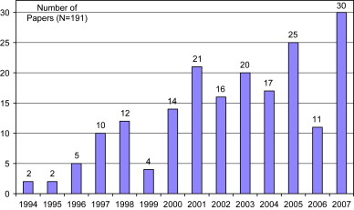

Figure 2.
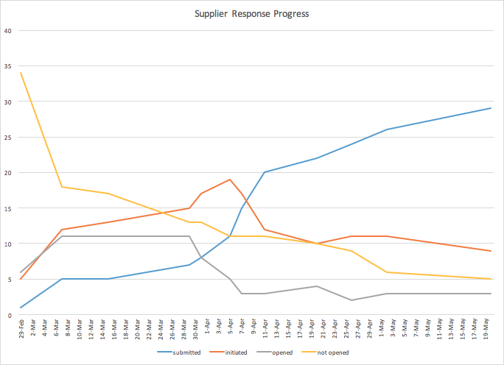

Figure 3.
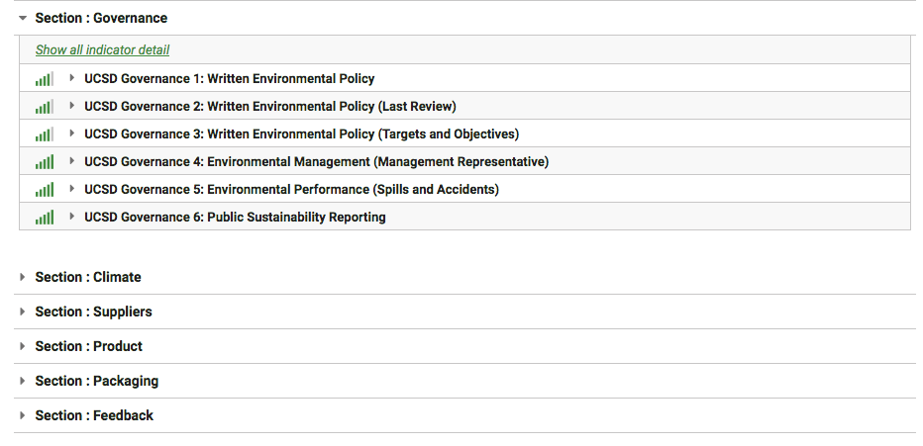

Figure 4.
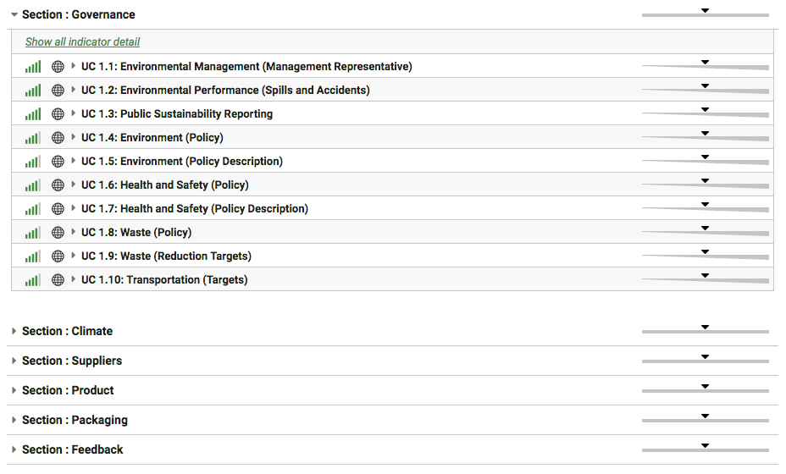

Figure 5.
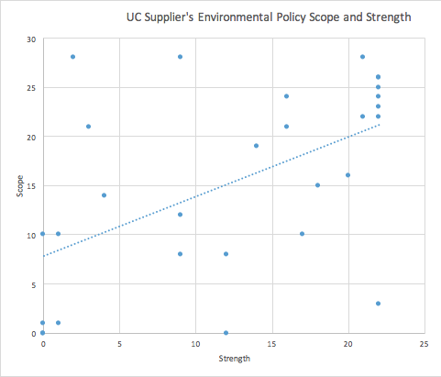

Figure 6.
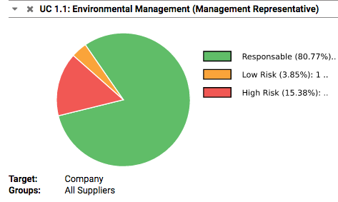

Figure 7.
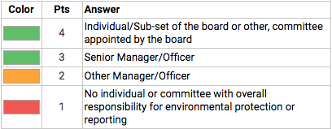
Figure 8.
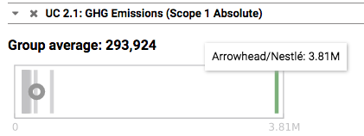

Figure 9.
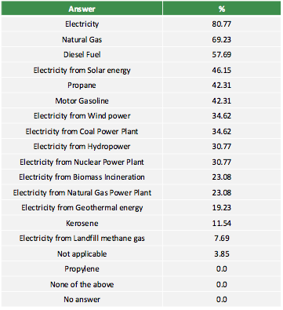

Figure 10.
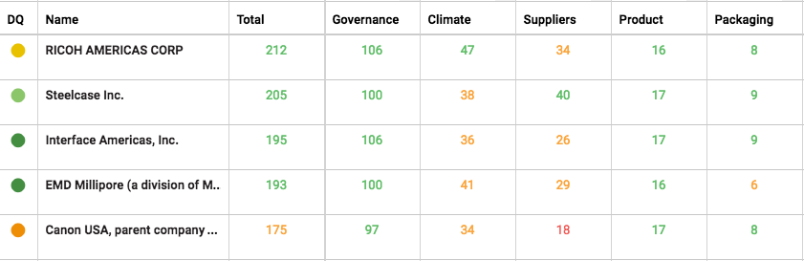

Figure 11.
