Provost's Sustainability Internship Program:
People of Color Sustainability Collective
Asian American Pacific Islander Resource Center
Ashoka Alvarez
Environmental Studies Major, 2017
assalvar@ucsc.edu
Mentor: Adriana Renteria
June 7th, 2017

Abstract:
The goal of the internship with the People of Color Sustainability Collective (POCSC) is to foster a campus climate that is open and inviting to all environmentalists regardless of income, background, or cultural practices, and to highlight and celebrate specifically students of color who may not feel represented in traditional environmental movements. As the Provost’s Sustainability intern, I worked in partnership with the Asian American Pacific Islander Resource Center (AAPIRC) to create an event in the spring that addressed Asian American sustainability. I was also tasked with compiling resources for the PoCSC website. In order to achieve these goals, I worked closely with both PoCSC and AAPRIC, and attended, planned, and executed various events and workshops for both organizations, as well as worked on focus groups led by PoCSC and attended conferences and retreats in order to improve my networking and facilitation skills. This internship has been successfully completed, having completed the final event during spring quarter, and uploaded the researched resources to the PoCSC website, however the goal of creating a welcoming campus culture is one that will be ongoing long after the end of the internship.

Introduction:
The University of California Santa Cruz is world renowned for being a leader in environmental sustainability. This year the university was named one of Sierra Nevadas top 20 greenest colleges, and is number seven in the Princeton Review list of top 50 greenest colleges, due to the research and programs offered here (UC Santa Cruz 2017). However, there are often challenges to engaging students in sustainable practices or sustainable culture here on campus in a manner that is culturally relevant and salient to people of all backgrounds. The People of Color Sustainability Collective (PoCSC) is a retention initiative that was created in order to address the issue of environmental justice, to create discussion space for students to celebrate their own form of POC sustainability, and create discourse around the idea of environmental racism. The term environmental racism was first coined in a report titled Toxic Wastes and Race in 1987 (Bullard et al, 2007). Historically, the zip code that a person lives in can be linked to predictions of health, class, and likelihood of certain diseases (AJ+ 2016). This means that a student's background before coming to UCSC can significantly influence their idea of sustainability and environmentalism.
Often sustainability is seen as something that can only be focused on when all other needs are taken care of, such as food and shelter, and therefore restricted to upper middle class communities. On the other hand, there is a racialization of environmentalism that leads to a perpetuation of stereotypes and cultural appropriation that can be damaging and offensive (Park, 2004). The elitism and racism that permeates many aspects of American culture also bleeds into sustainability. Anecdotally, some people of color have felt that others are surprised that Brown people go camping or enjoy the outdoors. Some students in focus groups run by PoCSC have expressed frustration with the university when it comes to addressing environmental justice issues alongside traditional environmental issues such as saving natural resources above all. Much of current environmentalism rhetoric subscribes to the idea that we should save national parks for hikers and eco-tourists at the expense of the indigenous people who traditionally live on that land, placing parks and scenery above the lives of the communities who have cared for that same land for generations. According to Priscilla Ybarra, “those living on the edge socially and economically often have thrifty habits out of necessity, but sometimes also out of cultural legacy,” and therefore these communities are often more sustainable than the white and wealthy (Ybarra 2016). In reality, we know that sustainability can take many forms, and that to fight for a more environmentally friendly world also means fighting for those who have no access to healthy food, clean water or air, or parks. In recognition of these various forms of sustainability, and the reality that environmentalism looks different to different communities, PoCSC strives to now make UCSC a leader in environmental justice, ensuring all students feel welcome to explore sustainability in a culturally relevant and accessible manner.

Project Description:
The goals I had for this year were to connect the Asian identity to environmentalism and sustainability, as well as provide resources and plan an event in which we addressed Asian American sustainability with students. Over the course of the year I have also worked on larger PoCSC and AAPIRC projects as support for events and tasks. Some examples of such projects include: executing focus groups and disseminating the information that we have received regarding our research on environmental culture on campus, being a committee member for the Asian American Heritage Month, facilitating workshops and events, and presenting at conferences.
My objectives for this year long internship is to develop my leadership and facilitation skills in order to assist in providing culturally relevant programs that engaged students in discussion regarding environmental racism and environmental justice. Each quarter I am assigned certain tasks in addition to planning my spring event, which will be planning out over the course of the whole year. In order to plan a successful spring event, I held meetings with my mentor, networked with folks at conferences and from campus organizations, and was an active member of both PoCSC and AAPIRC. The event was executed on May 3rd, 2017, as a partnership between the People of Color Sustainability Collective (POCSC) and the Asian American Pacific Islander Resource Center (AAPIRC) in honor of Asian American Pacific Islander Heritage Month.
The event, ‘Rooted in History: Asian American Resilience and Sustainability through Art’ centered itself around a discussion of specific environmental justice issues that affect AAPI communities in California, such as the impacts pollutants have on nail salons workers and how gentrification has affected the Chinatown communities in Oakland and San Francisco. We focused on organizations and campaigns that have served AAPI communities and are making strides to improve the quality of life for Asian families in California. For example, the Asian Pacific Environmental Network has lead numerous successful campaigns in the Bay Area and across California to cap emissions, empower and educate communities, and reduce harmful pollutants. We also highlighted some past leaders in Asian American history that have often been overlooked or forgotten such as Larry Itliong, a Filipino labor leader in Delano, California and one of the men who sparked the United Farm Workers grape strike in 1965. The purpose of this event was to celebrate our past victories and involvement in environmental justice, as well as to understand current issues that are affecting our communities.
Another part of my project is to compile resources for those who are interested in Asian American organizations in the area that focus on environmentalism, and provide links to these resources on the PoCSC website.
My internship is beneficial to UC Santa Cruz because we are able to foster discussion on campus about different types of environmentalists. We foster conversations and education, teaching the wider student body about forgotten AAPI leaders. This is in line with the goals of PoCSC, which are:
- Raising awareness about the contributions that people of color have made to the environmental sustainability movement in general and at UCSC in particular
- Reexamining the definition and values of the sustainability movement to identify how it can be more inclusive of all underrepresented populations
- Creating critical dialogue about environmental justice through student discussion spaces, student of color caucuses, social media awareness campaigns, workshops, and speaker presentations
We hope that these goals are beneficial to students of color who wish to see themselves represented on campus. Other options to combat these issues include other clubs or organizations dedicated to student of color sustainability, or mentorship program. Organizations at other schools such as UC Berkeley also have organizations similar to PoCSC, however we are one of the few that are seen as a retention initiative. When seen as a crucial aspect of keeping students on campus and happy with their quality of life here, we break the stereotype that environmentalism is a ‘white issue,’ and open the doors to allow access and accept all forms of environmentalism, and therefore accepting students of all backgrounds. In this way, the People of Color Sustainability Collective could be replicated across the UCs or other institutions who wish to address the issue of environmental justice.

Project Timeline:

Fall Quarter:
- Students Inspiring Leadership Retreat (SLI)
- Practical Activism Conference Workshop
- Begin planning project for spring quarter
- Keith Miyaki Event point person
- Calendar updates for events regarding environmental/social justice
- Planning for focus groups (questions, materials, general planning)
- General support for PoCSC and AAPIRC

Winter Quarter:
- Inter-Org
- Continue planning for event in Spring with a focus on budget and timeline planning
- Attendance of conferences and facilitation of workshops (CaCCHE Conference, Listen to the Silence Conference, Multicultural Career Conference)
- Focus group facilitation
- Heritage Month Committee (Decorations)
- Continued support for PoCSC and AAPIRC

Spring Quarter:
- Execute event on asian american sustainability
- Compile resources for Asian American sustainability
- Dissemination of PoCSC research
- Compile mural for Rooted In History event
- Heritage Month (May) support
- Continued support for PoCSC and AAPIRC

Project Stakeholders, Student & Mentor Roles:
PoCSC creates programming and events that are open to everyone on campus; however, the primary stakeholders would be students of color who wish to engage in environmentalism. We reach out to these students through connections to other organizations, flyering, and social media outreach, as well as through partnerships with other institutional entities, such as Colleges 9 and 10, the Sustainability Office, and the Ethnic Resource Centers.
The main actors in the project are myself, the PSI intern, as well as the other interns in PoCSC and AAPIRC, and my mentor, Adriana Renteria, who is the program coordinator for PoCSC. As the PSI intern, my role was to be a bridge between AAPIRC and PoCSC, as well as focus on the connection between Asian American cultures and sustainability. As my mentor, Adriana provides additional support for me by meeting with me regularly in order to stay on track with my project, and providing me with guidance and action items to cover each quarter. I also collaborate with other interns from both AAPIRC and PoCSC in all events we do, such as Heritage month or Community Welcome, by helping to design flyers and posters, outreach, setting up, facilitating workshops, and clean up. Most of our funding comes from the Ethnic Resource Centers, and well as funding from various college senates, which we apply for using the standard request for funding process.

Measurable Results:
The results of my specific internship can be quantified by calculating how many people came to my event. In addition to the results of my event in the spring, PoCSC will be disseminating the results of the focus groups and research that has been conducted over the course of the past two years during Spring Quarter. These results will look at the ideas students have of campus climate regarding students of color and sustainability, as well as specific thoughts that were discussed in the focus groups that were conducted this quarter. Although the data has been assembled, conclusions are still being made and no definitive answers about campus climate can be made. However, the study did show that students of color experienced more health threats in their hometowns than white non-hispanic students. Focus groups also discussed access to environmentalism, with several students of color expressing sentiments that environmentalism is much more than an issue about the natural world, but rather a social justice and environmental justice issue. The presentation of the research was held May 25th, from 4pm to 6pm in the Multipurpose Room in Colleges 9 and 10, and the artwork from the Rooted in History event was displayed there. While this research will be wrapped up at the end of this year, it does not provide a definitive statement on campus culture or thoughts, and we hope to simply add to the conversation in a manner that can be built and expanded upon.

References:
AJ+. Environmental Racism Explained. YouTube.com. Jan 29, 2016.
https://www.youtube.com/watch?v=TrbeuJRPM0o. Accessed 3/1/2017

Bullard et al. Toxic Waste and Race at Twenty. The United Church of Christ. March 2007.

Park, L and Pellow, D. Racial formation, environmental racism, and the emergence of Silicon Valley. Mapping Comparative Studies of Racialization in the US. 4(3) pp. 403-424.

UC Santa Cruz. 2017. Sustainability Office Awards. http://sustainability.ucsc.edu/about/awards.html

9. Appendices:
POCSC website: http://pocsc.ucsc.edu/
POCSC Facebook: https://www.facebook.com/pocsustainability/

Flyer designed for Keithy Miyake Event (lead organizer) and Rooted in History Event (sole organizer):
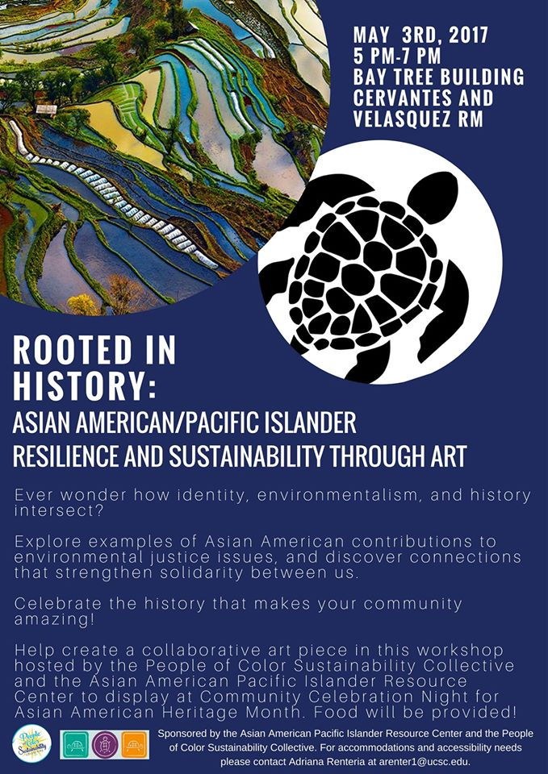
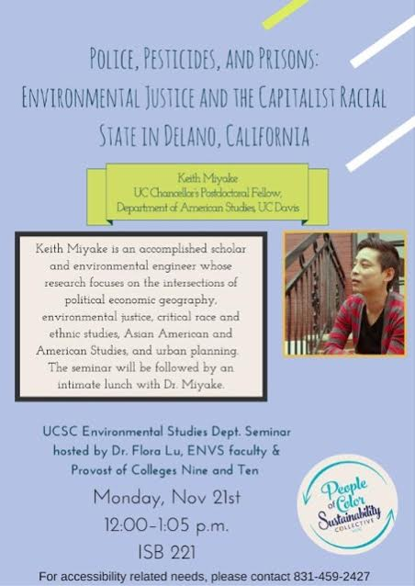

POCSC Logo and Team:
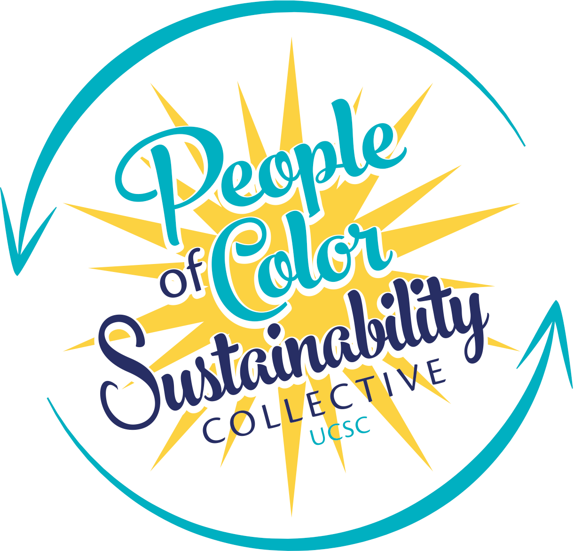

AAPIRC Team:
