Ecological Restoration and updating the Site Stewardship Grassland Monitoring Program

Edwin Colon
Plant Sciences major/ Sustainability Studies minor, Senior (emcolon@ucsc.edu)

Provost’s Sustainability Internship Program
Site Stewardship Program

Bill Reid (billreid@ucsc.edu)
Dave Roe(jdroe@ucsc.edu)

June 6th, 2016
Abstract

As the Provost Sustainability Intern for the UCSC Site Stewardship Program 2015-2016 I updated the grassland monitoring project by analysing data collected since 2009. I created management recommendations for grazed areas including East Meadow, Great Meadow, Lower Hagar, Inclusion Area A, and Marshall Field. I created a design for an interpretive sign for OPER intended as an outreach tool for educating the public on ecological issues on campus. Other outreach for the program was done through tabling events such as frosh orientation, volunteer fair, and student organization through volunteer days. I assisted Bill Reid with the 2-unit Environmental Studies Department quarterly internship. Since the summer of 2015 we have averaged 3 intern per quarter during the academic school year. Overall I believe my work with the Site Stewardship Program has advanced the student and community knowledge of ecological issues and natural history of UC Santa Cruz. Through further efforts like these I believe we can establish a stronger interest in preserving our natural habitats as well as understanding the implications of our individuals actions on those habitats.

Introduction

California offers unique habitats that support various ecosystems services that human benefit as well as local flora and fauna benefit from. UCSC alone contains various adjacent habitats including Coastal Prairie, Redwood forest, and riparian ecosystems. Proper land management through ecological restoration and species conservation is needed in the face of massive habitat degradation. With a ‘perfect storm’ of intense ecological stressors. such as elevated CO2 and intense climate events, we may soon experience the 6th mass extinction without proper mitigation plans (Barnosky et al. 2011). These are complex issues with no clear solution, sometime referred to as ‘wicked problems’. To solve them we must take an interdisciplinary approach that includes environmental economics, restoration ecology, public education, and policy change. Education has had the tremendous power to influence individuals and bring attention to the importance of these ecosystem services. Example like “Silent Spring” by Rachel Carson aided towards shifting public opinion on pesticides like DDT. The Site Stewardship Program (SSP) seeks to educate the public as well as offer student internship pertaining to ecological restorations. SSP addresses the Campus Sustainability Plan goals stated within the Land, Habitat, and Watershed section such as increasing student involvement in stewardship and restoration internships. SSP offers internships to students and volunteer days to the great Santa Cruz community to educate the public about our impact on our natural lands. Tasks include invasive species removal, native re-vegetation projects, native seed collection, plant propagation, and grassland monitoring projects. Active restoration techniques, like the ones described above, have increased the biodiversity and ecosystem services in various ecosystem types (Rey Benayas et al. 2009). Through community and student efforts we have been able to maintain various restoration sites as well as tackle large areas in which invasive species have taken a foothold.

Project Description and Goals

Maintain the amount of interns to 3/quarter

The majority of the hours for the PSI program was spent with the 2 unit interns crew performing active ecological restoration on different UCSC sites. We focus on areas that have been a source for invasive species, certain focus species include French Broom (Genista monspessulana) and Poison Hemlock (Conium maculatum). If left unchecked these species can create monocultures and inhibit native plant growth and wildlife passage. We also reroute trails and created water diversion features (e.g. water bars) to prevent erosion and sedimentation into waterways. Through proper management we aided in promoting native biodiversity as well as offered an area for sustainable human recreation. Many sites have a history of overgrazing and human alteration but resilient native species can return through proper land management techniques.
The tasks for each quarter of the internship changed with the seasons. For Summer/Fall we focused on invasive species removal, greenhouse propagation , and residual dry matter (RDM) monitoring. Winter was mostly native re-vegetation projects, we planted native species on an earthen berm between the Long Marine Lab and the Lagoon. Spring was more invasive removal and spring grassland monitoring. Our sites range all over campus property, we commonly collaboration with the UC Natural Reserves Systems and the UCSC Thimann Greenhouses. Potential interns were reached during outreach events and through a low volume email listing. In the emails we outlined the work we planned for the upcoming quarter and potential work times. Katie Monsen was our Faculty Sponsor for our 2-unit interns through the ENVS department.

Update restoration/grassland monitoring data
This project spanned Winter and Spring quarter with Dr Karen Holl, professor of Restoration Ecology, as my faculty advisor. I inputted and analysed data from 2009-2015 for 5 UCSC monitored grassland sites (East Meadow, Great Meadow, Lower Hagar, Inclusion Area A/’Mimas Mounds’, and Marshall Field). We monitored for Residual Dry Matter (RDM) in the fall to estimate amount of ‘feed’ per acre. Grazing is also quantified using Animal Unit Months (AUM) to estimate the ‘feeding potential’ of a herd. In the spring we monitor variables that include canopy height, litter depth, % bare ground, % vegetative cover, % native grass, and % native forbs. This data has been tracked since the creation of the monitoring project in 2004. Our objectives include improving fire safety and native species abundance on grassland at UCSC.
Past student (Self 2004, Lynn 2007) had created the monitoring project but nobody had updated it since 2007. This project allowed me to experience the obstacles faced when doing independent research, writing a scientific research paper, and gave me a chance to use data analysis tools like JMP. A management plan with recommendations was offered to UCSC Grounds Services and an updated data graphs were presented in my research paper.

-Outreach via updated website, social media, and mini film series

Facebook website was updated with recent projects and volunteer opportunities. The website located at www.physicalplant.ucsc.com domain was also updated with photos of many projects mentioned above. Many tabling events were done early in the year including Frosh orientation, OPERS fall fest, Haybarn events, as well as various environmental oriented tabling events. The mini film project is intended to highlight ecological issue through mini videos explain things ranging from invasive species spread to erosion from ad hoc trails. These videos are intended to show examples of these issues on campus as well as solutions through internship opportunities.

-Create and implement interpretive sign

We have written text for the panels as well as a work order for the carpenter shop to make the sign. The project was delayed since Stormwater Management could not collaborate in the sign design. The panel subject include erosion/ad hoc trails, UCSC natural history, and volunteer opportunities sections. Unfortunately the sign shop has various work orders related to spring graduations so this project will continue into next year. This project is intended to educate the public of our natural history as well as restoration efforts on campus.

Some goals I had created throughout the quarter were not accomplished due to the needs of the SSP, time constraints, or skill limitation. Such projects included grant writing for a part-time Stewardship position for the SSP, a GIS mapping project for invasive/native species location, and other small projects that were not able to be accomplished within this time frame.

Project Timeline

-Create and implement interpretive sign

Oct 1st-Begin talking about the idea and the interest from Stormwater Management
Feb 1st- After many month of discussion Stormwater Management will not be able to collaborate on the sign
April1st-Begin sign design and the panel text
March 30th- Complete panel text and collect various photos of local UCSC habitats, leave a outline for future PSI to continue this project

-Outreach

August 15-30th- Frosh orientation tabling
October 21st- Volunteer fair tabling
October 24th- Haybarn historic fair tabling
November 20-30th- Class raps in introductory ENVS and BioE courses
April 23rd- Sigma Pi volunteer day at Cowell firehouse
May 14th- Sigma Pi and ENVS intern volunteer day

-Update restoration/grassland monitoring data

Dec 10th- Begin meeting with Dr Holl and established the idea for grassland update. Begin transfering years of data into excel and using JMP to create regression analysis of the data
Feb1st-Begin rough drafts and editing process with the advising of Dr Holl
April1st- Extend the soft deadline further given the massive scope of the project
April 15th- Complete final paper of California Coastal Prairie ecology, UCSC site history, current management plans, data analysis, and grazing management recommendations for the grasslands. Final paper was revised by Dr Karen Holl and was given to the UCSC Grounds Services Department.

Project Stakeholders, Student & Mentor Roles

Bill Reid is the internship coordinator for the Site Stewardship Program, responsibilities range from intern management to site assessment for workdays. I would work with Bill at least twice a week along intern crew understanding how to assess restoration sites, maintain volunteer moral, and how to understand general ecology. His knowledge of the campus has aided me in creating the management recommendations and he has taught me

Dave Roe is the assistant superintendent of the UCSC Grounds department and is key for implementing things like the interpretive sign as well as acquiring funds for the Site Stewardship Program. We would meet weekly to discuss ongoing projects and offered me support in personal projects as well as revisions of final papers. His assistance was key to understanding the limitation of the Grounds Services Department and it help me better create personal projects. His connections within the campus has aided us to further restoration efforts on campus.

Dr Karen Holl is a professor in the Environmental Studies department that was my faculty advisor for my grassland monitoring project. She aided me in creating the project idea, data analysis, and science writing. She was pivotal in the creation and review of the grassland management project, I reached out to her personally from the recommendation of the ENVS office since I was seeking a ENVS faculty sponsor.

Tim Brown is the Reserve Steward for the Younger Lagoon UC Natural Reserve located near the Seymour center. The SSP Earthen Berm is located in Younger Lagoon and through collaboration we maintain the site as well as adjacent areas.

Alex Jones is the UCSC upper campus Reserve Steward, he is responsible for the majority of upper campus as well as ongoing research in the Forest Ecology Research Plot (FERP) as well as various biological monitoring programs within the FERP. We have collaborated in work in the upper campus including restoration of the Crown Meadows with native grass species.

Katie Monsen is the faculty sponsor for many 2 unit ENVS internships including Site Stewardship Program interns. She is a lecturer for the ENVS department teaching Freshwater Ecology, Sustainability Praxis, and Agroecology Practicum.

Measurable Results

-A research paper on the Grassland Monitoring status from 2009-2015
It will include a complete analysis and management plan for the 5 UCSC grassland site. It covers land use history as well as important ecological conditions, it is focused on the impact of grazing on native species abundance. Through different management plans we can have differing outcomes to improve native species abundance, maintain fire safety, provide habitat for the endangered Ohlone Tiger beetle. Each site is unique and harbor different exotic/native species, our data is long term and has collected monitoring since its creation in 2004 by Jamie Self as a senior internship project.

-A completed interactive sign design
This will outline the importance of these ecosystems as well as individual’s action that can help maintain our natural lands. It will highlight past project like the work done on the adjacent hillside as well as other work done by the SSP.

-Student email listing
For direct student and community outreach we attended frosh orientation and other local tabling events during fall quarter. During these events we spoke about the program and showed photos of past restoration projects. We offered student internships and volunteer events by collecting emails for our newsletter. In total we received 350+ new emails through this outreach effort

-ENVS internship
We offer a 2-unit quarterly internship through the environmental studies department with Katie Monsen as our faculty advisor. I was a part of this internship since the summer of 2015 and co supervised the internship. Throughout the internship we had a total 11 interns not including Bill Reid and myself.

-Updated facebook page
The facebook page “Site Stewardship Program: UCSC's Habitat Fun Facts” was updated after volunteer events. Photos of interns and past projects were also highlighted. “Likes” and “Follows” were recorded and totalled to ~25 likes and ~5 new followers. This was not an objective of mine but it is a measurable result of outreach.

References

Barnosky, A. D., Matzke, N., Tomiya, S., Wogan, G. O., Swartz, B., Quental, T. B., ... & Mersey, B. 2011. Has the Earth's sixth mass extinction already arrived?. Nature, 471(7336), 51-57.
Benayas, José M. Rey, et al. "Enhancement of biodiversity and ecosystem services by ecological restoration: a meta-analysis." Science (2009).
Lynn, L. 2007. UCSC Site stewardship grassland monitoring program progress report. Senior internship project, University of California, Santa Cruz.
Self, J. 2004. Development of a UCSC Grassland Monitoring Program. Department of Environmental Studies. University of California Santa Cruz.

Appendices

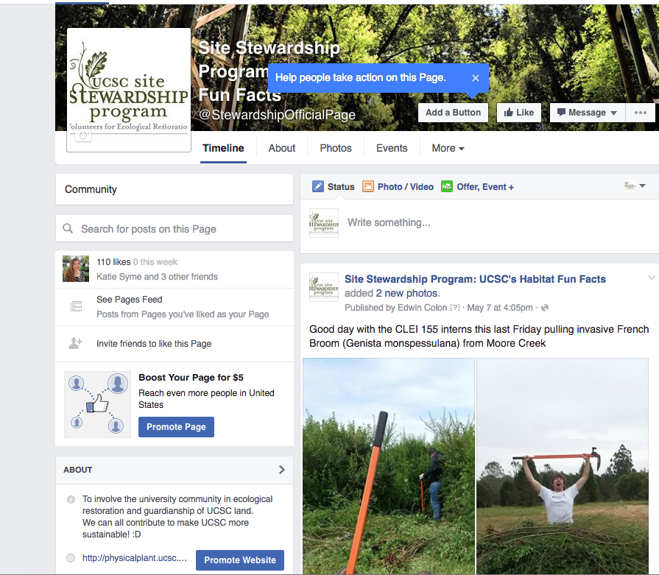
Site Stewardship facebook page
