UCSC Site Stewardship Grassland Monitoring Program report

Edwin Colon

2016

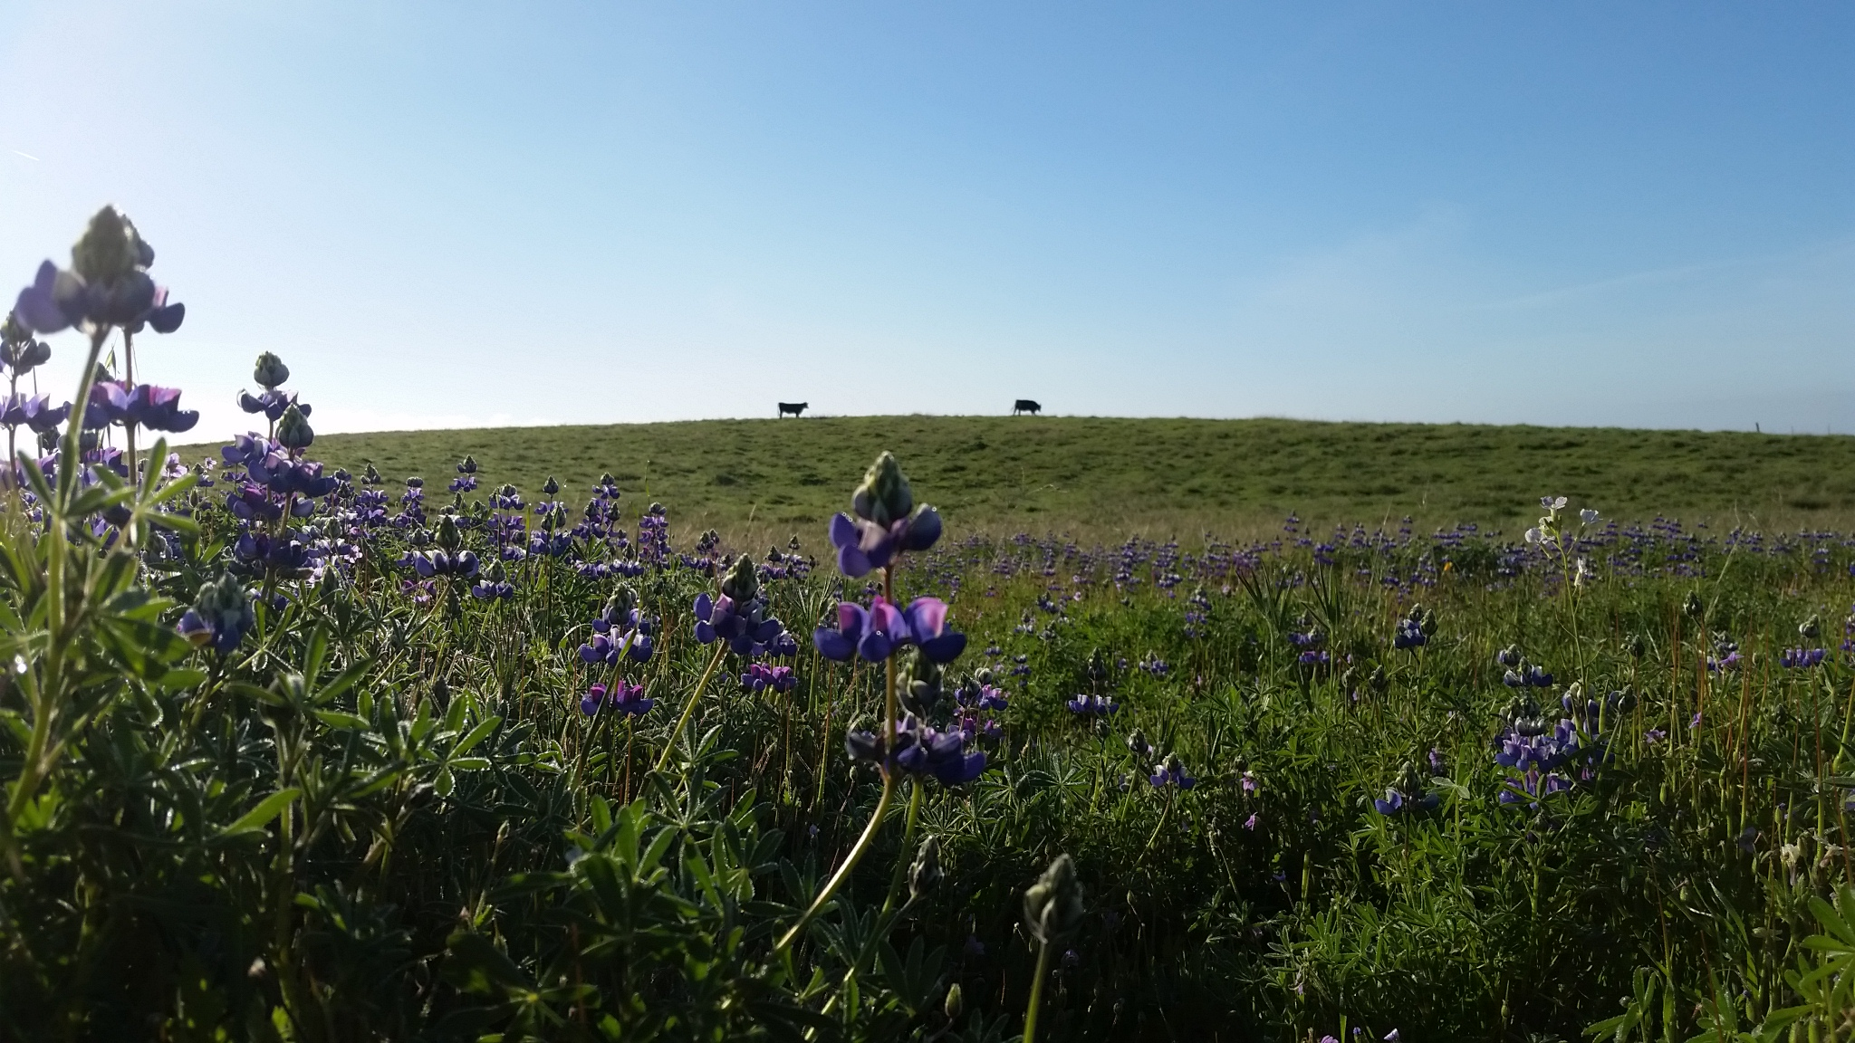
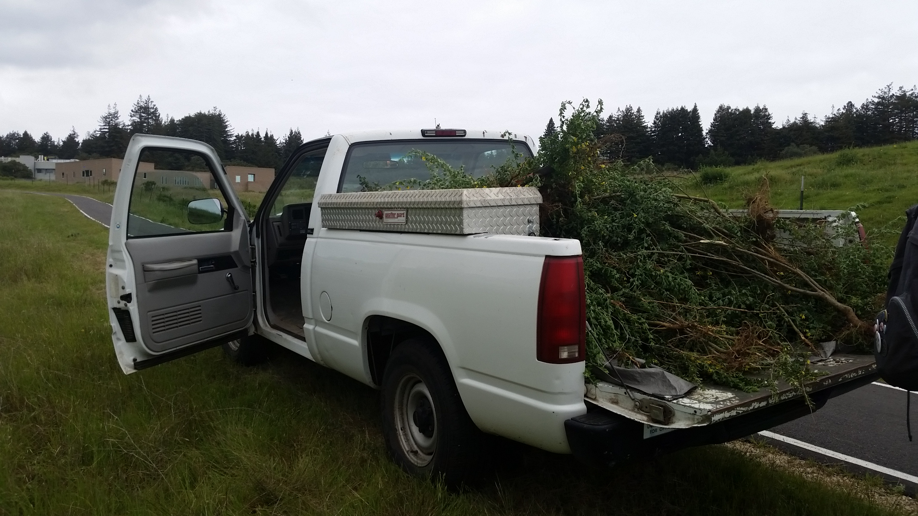

Acronyms

AUM Animal Unit Months
CCP California Coastal Prairie
CNPS California Native Plant Society
EF East Field
GM Great Meadow
HCP Habitat Conservation Plan
IAA Inclusion Area A
LH Lower Hagar
MF Marshall Field
OTB Ohlone Tiger Beetle
PSI Provost’s Sustainability Intern
RDM Residual Dry Matter
SSGMP Site Stewardship Grassland Monitoring Program
SSP Site Stewardship Program
UCSC University of California, Santa Cruz

Introduction
As the Provost Sustainability Intern (PSI) for the 2015-2016 academic years I have worked towards updating the data for the UCSC Site Stewardship Grassland Monitoring Program (SSGMP). This project was established by Jamie Self in 2004 and outlined California Coastal Prairie ecology, UCSC management history, and implemented a protocol for collecting monitoring data. The project was updated by Lucy Lynn in 2007 and documented changes to the SSGMP, data collection protocol, and provided management objective and recommendations for the UCSC Grounds Services Department. This report is intended to update changes in the SSGMP since 2007 to inform the UCSC Grounds Services the effectiveness of grazing treatments on Coastal Prairie.
Coastal Prairie and management goals
The Coastal Prairie ecosystem is generally patchily distributed in California and Oregon occurring within 100km from the coast, less than 1000m in elevation, and frequently found on ridges and south facing hillsides (Heady 1988). This ecosystem experiences a Mediterranean climate with wet winters and dry summers where fog is common. The University of California, Santa Cruz campus is 2001 acres and contained patches of California Coastal Prairie (CCP). Common flora found within CCP includes perennial bunch grasses such as Stipa pulchra (purple needlegrass) and Danthonia californica (California oatgrass). Native forbs include Lupinus spp. (lupine) and Sidalcea spp. (checkerblooms) (Stromberg 2001). Many of the UCSC sites support rare and endangered species such as the Ohlone Tiger Beetle (Cicindela ohlone) and Plagiobiothrys reticulates var. rossianorum (San Francisco popcorn flower) (Self, 2004). Unfortunately many of these ecosystems have faced extensive habitat loss from human development and invasive species spread. Currently there are 18 federal and state listed endangered plant species in the CCP ecosystem (CNPS 2016). Management tool are necessary more than ever to maintain and restore native species abundance and deter potential fire hazards.
The CCP once dominated most of the coastline but through shifts in management practices many have lost their native species abundance. Through fossil record and plant adaption studies large North American ungulates are believed to have historically grazed mesic grasslands like CCP. Grazing reduces biomass, woody species encroachment, and may benefit certain native species (Hayes and Holl 2003). The Spanish introduced high intensity cattle grazing to North America in the 18th century shifting the dominant grazing away from the pronghorn antelope (Antilocarpa americana) and tule elk (Cervus elaphus nannodes) (Self, 2004). Dominant grazers have remained cattle and wild deer (Odocoileus hemionus) for most monitored plots. Peak livestock densities and severe prolonged drought in the late 1800s are debated as the mechanisms responsible for the shift in species composition from native perennial bunchgrass to non-native annual grasses and forbs (Marty 2005). Certain plants are disproportionately selected against by grazing through morphological adaptations or general unpalatability to cattle. Invasive species like wild slender oat (Avena barbata) and French broom (Genista monspessulana) dominate many of our monitored sites. Cultivated sites also have shown lasting impacts on native species and their seed banks via mechanized tilling (Stromberg 1996). A proper management plan should be developed to reduce invasive species spread, improve fire safety, and native species abundance.
The timing of grazing and local climate is very important for developing management objectives in CCP. Early spring grazing is recommended for optimal livestock feed and targets faster germinating invasive species, but risks potential soil compaction (D’Antonio et al 2002, Dyer 2003). In most UCSC grazed sites soil moisture is assessed by the rancher Pete Arvelas before grazing begins. For Inclusion Area A (IAA) grazing times have been predetermined by the UCSC Ranch View Terrace Habitat Conservation Plan (HCP) to be between May 15th and October 31st. These dates were established to deter trampling of the endangered Ohlone Tiger Beetle (OTB) burrows. Weather conditions vary annually and can have a drastic effect on site conditions and native species. Well-timed pulses of prolonged precipitation events can optimize the amount of water that will infiltrate the soil and minimize evaporation and runoff (Loik et al 2004). Intense rain events have a tendency to not completely infiltrate the soil. Recent drought conditions have stressed native species and have created potential wildfire hazards during summer season.
Finally, another key factor to CCP ecology is the role of fire on the landscape. It can be naturally occurring through lightning events but burn frequency suggests that indigenous groups may have used fire as a management tool (Self 2004). It is believed that burning discourages woody species encroachment and improves hunting conditions. Plant adaption studies have found post-fire and grazed Stipa pulchra (purple needle grass) experienced higher germination rates and larger adult plant size (Dyer 2002). These plant adaptions give evidence to the potential evolutionary dynamics between CCP, fire, and grazing. Unfortunately prescribed burns have not been used as a management tool in UCSC for decades and grassland fuel loads have built up. More woody species have become established, in particular Baccharis pilularis (coyote brush), increasing the risk for higher temperature fires that negatively impact native seed and adult plant survival. The UCSC Grounds Department has mowed perimeters, trails, and entire grasslands in some cases for fire safety. Although mowing does reduce potential fire hazards it leaves biomass that reduces light penetration and ultimately reduces seed germination. Grazing is the most pragmatic management tool for improving fire safety and potentially increasing native species cover.

Goals
The goals of the Grounds Services for CCP management are to improve fire safety and native species cover on the campus.

Objectives
-Fire Safety: Minimum residual dry matter (RDM), for coastal prairie with 0-10% slope and 0-25% woody cover, should be 1,200 lbs/acre (Bartolome 2006). Average litter depth should remain below 8cm and percent bare ground should remain below 15%.
-Increase Native Species Cover: Native species cover per grassland should not drop below 5% and should increase annually.

Methods
Precipitation data were collected from the De Laveaga weather station. The data were grouped into ‘growth seasons’ which spans from October 1st to September 30th of the next year. Animal Unit Months (AUM) were calculated by recording grazing density and duration, this was then divided by sites area for AUM/acre. The data are stored on the SSP server and were analyzed using JMP software. The methods for data collection for RDM and Spring Monitoring have not changed since the last SSGMP report in 2007 which is quoted verbatim below.

[ In the spring, late April through early May, data on vegetation characteristics including canopy height, litter depth, percent bare ground, and percent native species cover are collected while in the fall, late September through early October, data on Residual Dry Matter (RDM), a measure of biomass, are monitored. Permanent transect starting points are established in each grassland; ten in both East Field and Great Meadow, four in Lower Hagar, twelve in Inclusion Area A, and nine in Marshall Fields.
From each transect starting point, a 50-m tape measure is stretched out in a straight line along a randomly selected bearing to create transects. Each year a new bearing is randomly chosen and used for all transect starting points and for both fall and spring monitoring of that year (Self 2004). Six plots are sampled per transect at 5-m intervals along the measuring tape. A 0.5 × 0.5 m quadrat is used to sample spring variables while a 0.4 × 0.4 m quadrat is used to sample RDM in the fall. Quadrats are placed flush along the left side of the transect tape with the bottom left-hand corner at the sample point.
Canopy height is measured by placing an articulated 85-cm pin-flag in the center of the quadrat and spinning an impaled paper plate around it. The mark on the pin-flag where the plate comes to rest is recorded as the average canopy height.
Litter depth is measured along the pin flag by determining the highest intersection from the ground with the dead, dry, non-erect plant material.
Percent bare ground and percent native bunchgrass is visually estimated within quadrats. Paper squares representing 10%, 20%, 30%, or 40% are used as guides to help calibrate the visual estimates. Percent cover values are then assigned to percent cover classes and the midpoint value of each cover class is used for analysis, (Self 2004) originally used 10 % cover classes (0, 1-10, 11-20, 21-30…), but found these were too coarse for native perennial grasses which rarely had higher cover than 10%. The ranking system is now used to obtain a better representation of the abundance of native perennial grasses.
RDM collection is designed closely following the guidelines offered by Bartolome 2006. Each plot is entirely clipped of all the above ground dry matter within the quadrat while effort is made to not collect any underground root biomass or soil. The samples are then dried and weighed to determine biomass.
Other data collection includes notes such as presence of gopher or ground squirrel activity in the plot, mowed plots, or plots on trails] (Lynn 2007).
The relationship between our monitoring variables and precipitation and AUM/acre were using regression analysis. A p-value<0.05 was considered significant.

Site updates since 2007
Great Meadow: In 2012 a fence was built in the eastern end of the Great Meadow to reintroduce grazing since its removal in 1990. The majority of transect points were located within the fenced area. Bicycle and hiking trails are mowed annually for fire safety. An east- to west ‘belt’ is mowed annually as an additional measure for fire safety.

Inclusion Area A (IAA): Grazing times have been predetermined by the UCSC Ranch View Terrace Habitat Conservation Plan (HCP) to be between May 15th and October 31st. These dates were established to deter trampling of the endangered Ohlone Tiger Beetle (OTB) burrows. OTB populations are monitored and an annual summary report is provided by the UCSC Grounds Service Department to the U.S. Fish and Wildlife Service (USFWS). A small fire in the northern end of the plot occurred during summer 2013; some transect plots were burned but did not seem to strongly effect the data.
Lower Hagar: In 2014 the Center for Agroecology and Sustainable Food Systems (CASFS) fenced the northern portion of the Lower. Site monitoring and grazing was discontinued that year.
Marshall Field: Although permits were obtained for a prescribed burn, the 2009 Lockheed fire in Bonny Doon, CA caused all fire permits to be suspended. Since then there has been little effort towards obtaining another permit by the UCSC Grounds Services Department. The site is entirely mowed as needed with most recent being in 2013.

Results

Rainfall year was the sum of all precipitation between October 1st and September 31st of the following year. Rainfall year was highest in 2011, followed by a decline in annual precipitation until 2014 (Fig 1). Residual dry matter (RDM) for most sites remained between 750-1500 lb/acre, Lower Hagar declined below this RDM in 2013 until the plot was abandoned in 2014. The East and Great Meadow both experienced RDM above 1500 lb/acre in some recent years (Fig 2). Animal unit months (AUM)/acre were lowest for the East Meadow. For all other grazed sites AUM/acre fluctuated between 1 and 2.5 (Fig 3). Mean bare ground remained below 10% for most sites with the exception of Lower Hagar and IAA. Lower Hagar experienced a spike in bare ground only in 2011. IAA bare ground fluctuated around 10% beginning in 2011 (Fig 4). Native grass cover remained below 10% for most sites; Lower Hagar experienced a rise in 2012 until monitoring was discontinued in 2014. Marshall Field had the highest native grass cover remaining above 20% (Fig 5). Native forb cover has remained below 7%; most sites fluctuate inter-annually but no increasing trends are evident. There have been no native forbs recorded in Lower Hagar during this monitoring study (Fig 6).
Mean vegetative cover peaked during 2010 for most sites and has decreased thereafter. The Great Meadow experienced the largest fluctuation in vegetative cover between 2010 and 2012 (Fig 7). Mean canopy height fluctuated between 20 and 50 cm for monitored plots (Fig 8). Litter depth has remained below 10cm for most sites; Marshall Field initially experienced the highest litter depth but this trend has declined in recent years (Fig 9).

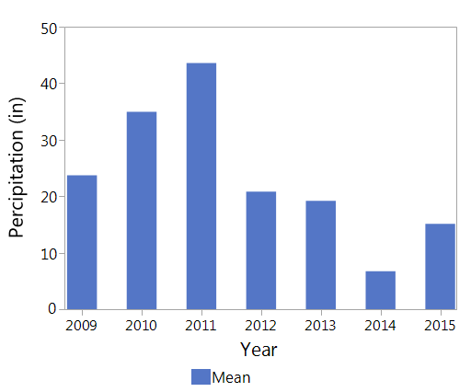
Figure 1: The annual rainfall year (Oct 1st -Sept 31st) from 2008-2015. Data from the De Laveaga weather station, CA. Recorded in inches, summed at the end of each rainfall year.

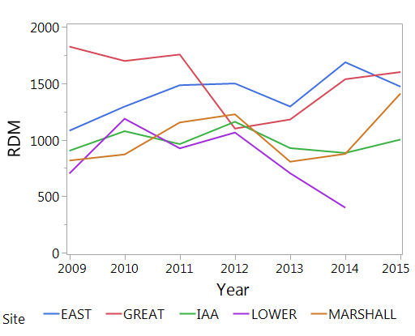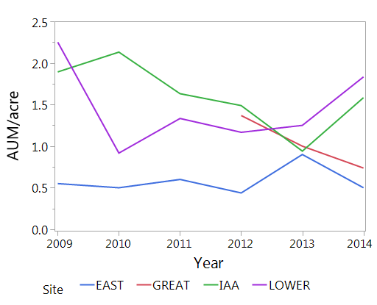
Figure 3: Animal unit months (AUM) per acre from 2009 to 2015, Marshall Field excluded.

Figure 2: Residual dry matter (RDM) from 2009 to 2015 for each monitored site, recorded in lb/acre.

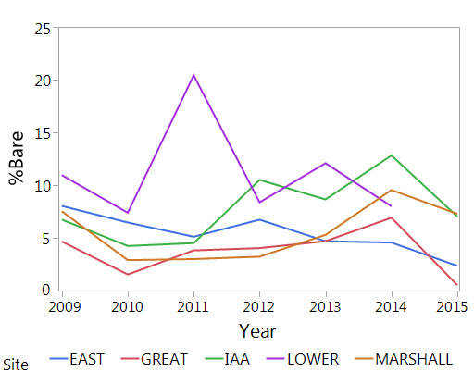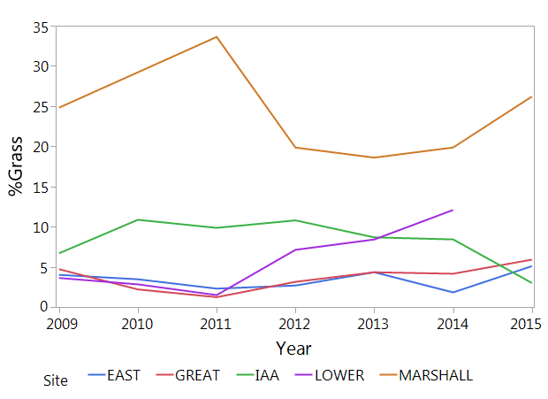
Figure 5: Mean percent native grass from 2009 to 2015 for each monitored site

Figure 4: Mean percent bare ground from 2009 to 2015 for each monitored site

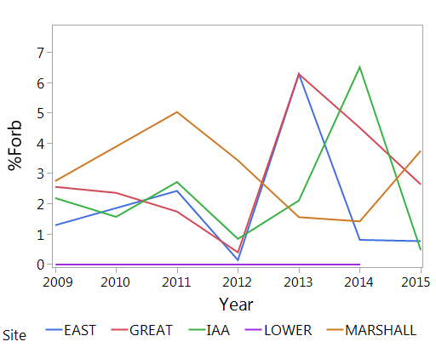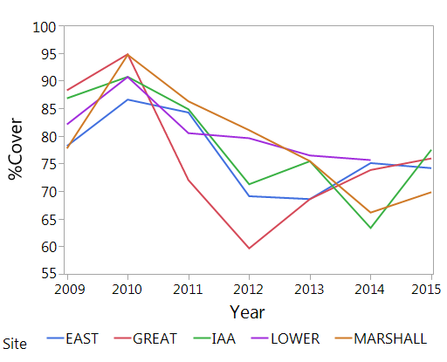
Figure 7: Mean percent vegetative cover from 2009 to 2015 for each monitored site

Figure 6: Mean percent native forbs from 2009 to 2015 for each monitored site

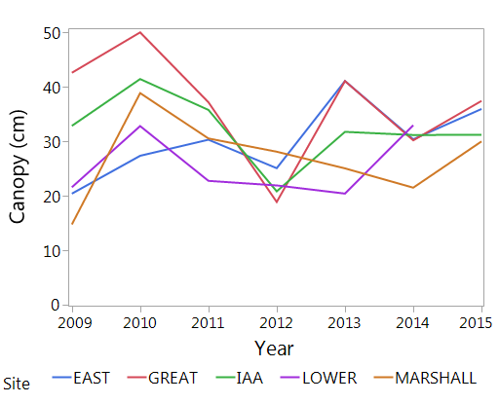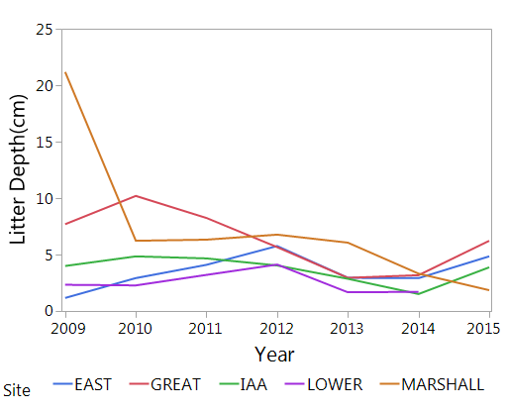
Figure 8: Mean canopy height (cm) from 2009 to 2015 for each monitored site

Figure 9: Mean litter depth (cm) from 2009 to 2015 for each monitored site

The strength of correlation between precipitation, AUM/acre, and monitored variables varied heavily across sites and variables measured. In the East Meadow there were no significant correlations with any monitored variable and no correlations were observed for RDM, percent native forb, and canopy height for any site (Table 1&2).

Table 1: Correlation statistics for precipitation from 2009-2015. Significant p-values (p < 0.05) are highlighted.
Precip | RDM |  | Litter |  | %Bare Ground |  | %Grass |  | %Cover |  | %Forb |  | Canopy
 | r² | p | r² | p | r² | p | r² | p | r² | p | r² | p | r² | p
EM | 0.11 | 0.4645 | 0 | 0.9961 | 0.11 | 0.4583 | 0.02 | 0.7817 | 0.51 | 0.0697 | 0.31 | 0.7364 | 0 | 0.6173
GM | 0.16 | 0.3668 | 0.61 | 0.0387 | 0.12 | 0.4447 | 0.64 | 0.0314 | 0.08 | 0.5355 | 0.19 | 0.3252 | 0.16 | 0.3713
IAA | 0.07 | 0.5765 | 0.68 | 0.0218 | 0.72 | 0.0161 | 0.21 | 0.2979 | 0.63 | 0.0323 | 0.11 | 0.4523 | 0.26 | 0.2374
LH | 0.51 | 0.1134 | 0.15 | 0.4479 | 0.40 | 0.1772 | 0.88 | 0.0055 | 0.38 | 0.1895 | N/A | N/A | 0 | 0.8119
MF | 0 | 0.9571 | 0.04 | 0.6789 | 0.63 | 0.0324 | 0.63 | 0.0609 | 0.76 | 0.0102 | 0.60 | 0.0695 | 0.24 | 0.2623

Table 2: Correlation statistics for Animal Unit Months (AUM)/acre from 2009-2015. Significant p-value (p < 0.05) are highlighted. Marshall Field excluded due to no grazing.
AUM/  acre X | RDM |  | Litter |  | %Bare Ground |  | %Grass |  | %Cover |  | %Forb |  | Canopy
 | r² | p | r² | p | r² | p | r² | p | r² | p | r² | p | r² | p
EM | 0.09 | 0.5741 | 0.07 | 0.6249 | 0.21 | 0.3575 | 0.35 | 0.2173 | 0.11 | 0.5181 | 0.99 | 0.0002 | 0.68 | 0.0444
GM | 0.04 | 0.7018 | 0.77 | 0.3218 | 0.85 | 0.2545 | 0.70 | 0.3664 | 0.99 | 0.0325 | 0.56 | 0.4619 | 0.35 | 0.5986
IAA | 0.04 | 0.7018 | 0.25 | 0.3078 | 0.23 | 0.3413 | 0.01 | 0.8405 | 0.33 | 0.2319 | 0 | 0.9214 | 0.25 | 0.3164
LH | 0.52 | 0.1022 | 0.09 | 0.5653 | 0 | 0.9798 | 0.04 | 0.7211 | 0.14 | 0.4643 | N/A | N/A | 0.03 | 0.7421

Discussion

Most monitored sites, with the exception of the East and Great Meadow, had a RDM below 1200 lb/acre. The litter depth remained below 8cm and percent bare ground remained below 15% for all sites. This suggests that the fire safety objective has been met for most sites. The East Meadow experienced the least AUM/acre as well as predetermined grazing schedules outlined in the UCSC Ranch View Terrace HCP. This reduced grazing density and duration may have affected the monitored RDM. The Great Meadow reintroduced grazing in 2012 and corresponded with a decline in RDM, although subsequent years a rise in RDM was observed. The East and Great Meadow both have RDM higher than the recommended 1200 lb/acre, but achieved recommended litter depth and bare ground. Litter depth provides an indicator of potential wildlife threat and bare ground provides potential fuel break during a wildfire (Self 2004). These data suggest that for the East and Great Meadow marginal fire safety has been achieved.
Native forbs have remained below 8% with no trends suggesting an increase in grazed sites. Native grass has remained below 10% for most sites, Lower Hagar increased above this before monitoring was discontinued in 2014. The highest percentage of native grass monitored was in Marshall Field, an un-grazed site. The lack of increasing native species abundance in grazed sites suggests that the native species objective has not been met. It is difficult to observe native grass responses to recent grazing, as in the Great Meadow, due to their slow growth (Lynn 2007) and low initial cover. Other confounding factors like land management and un-documented land use can radically affect the native adult species and seed bank. For example, Lower Hagar observed no native forbs suggesting a lack of a viable seed bank. Marshall Field is noted to have a history of controlled burns, with most recent occurring in 1999, and little to no documented history of grazing or tilling (Self 2004). Rare species like Plagiobiothrys reticulates var. rossianorum (San Francisco popcorn flower) and the Ohlone Tiger Beetle (Cicindela ohlone) have been found in Marshall Field, although they have faced habitat disruption from mountain bikers and hikers.
Other observed trends may be due to confounding factors beyond the scope of this monitoring project. Initially I believed precipitation would have been correlated with RDM and canopy height although no statically significant correlations were observed. The rancher Peter Arvelas had noted that in 2014, a severe drought year, Avena spp had been observed to be over 1m in height in many grasslands of Northern California (Bill Reid 2016 pers. Comm). Canopy height is very sensitive to phenological timing, most recent grazing, and provides little data with respect to management objectives (Lynn 2007). Other confounding factors may have affected CCP growth and/or the data collection process that could not be identified in this monitoring update.
Recommendations
From these result I offer the following management recommendations:
1) Earlier and more intense grazing in non-HCP grassland to reduce invasive species cover, decrease RDM, and potentially increase native species abundance.
2) Increase fenced grazing area in the Great Meadow to reduce potential fire hazards and further monitor CCP responses to grazing treatments.
3) The UCSC Grounds Services should pursue a prescribed burn permit for Marshall Field in lieu of grazing management.
4) Create fenced areas in the OTB reserve of IAA and areas of Marshall Field to prevent habitat disruption from hikers and mountain bikers.
5) Discontinue collecting canopy height in spring monitoring. Begin monitoring litter depth during fall RDM data collection.
6) Collect and propagate native coastal prairie seed for habitat restoration to better meet SSGMP objective of increasing native species abundance
Acknowledgments
Dr. Karen Holl, Dr. Grey Hayes, Scott Loosley, Jamie Self, and Lucy Lynn were vital in the creation and implementation of the SSGMP. Dave Roe, Bill Reid, and countless SSP interns maintained and collected the essential data for this monitoring update. Dr. Karen Holl also provided crucial advisement in the statistical analysis and editing of this document.

Work Cited

Bartolome, J.W., J.S. Fehmi, R.D. Jackson, B. Allen-Diaz. 2004. Response of a native perennial grass stand to disturbance in California’s coast range grassland. Restoration Ecology. 12(2):279-289.

Bartolome, J.W., W.E. Frost, N.K. McDougald, and J.M. Connor. 2006. California guidelines for Residual Dry Matter (RDM) management on coastal and foothill annual rangelands. Univ. Calif. Div. Agric. Nat. Res. Rangeland Management Series Pub. 8092 (revised). 8p.

CNPS, Rare Plant Program. 2016. Inventory of Rare and Endangered Plants (online edition, v8-02). California Native Plant Society, Sacramento, CA. Website http://www.rareplants.cnps.org [accessed 18 February 2016].

D’Antonio, Carla, et al. "Ecology and restoration of California grasslands with special emphasis on the influence of fire and grazing on native grassland species." Report to the Packard Foundation (2002).

Dyer, A. R. 2002. Burning and grazing management in a California grassland: Effect on bunchgrass seed viability. Restoration Ecology. 10(1): 107-111

Dyer, A. R. 2003. Burning and grazing management in California grassland: growth, mortality, and recruitment of Nassella pulchra. Restoration Ecology. 11(3): 291-296.

Hayes, G.F. and K. Holl. 2003. Cattle grazing impacts on annual forbs and vegetation composition of mesic grasslands in California. Conservation Biology. 17(6): 1694-1702.
.
Heady, Harold F., et al. "Coastal prairie and northern coastal scrub." Terrestrial vegetation of California. California Native Plant Society, Sacramento 1002 (1988): 733-760.

Loik, Michael E., et al. "A multi-scale perspective of water pulses in dryland ecosystems: climatology and ecohydrology of the western USA." Oecologia 141.2 (2004): 269-281.

Lynn, L. 2007. UCSC Site stewardship grassland monitoring program progress report. Senior internship project, University of California, Santa Cruz.

Marty, J. T. 2005. Responses of a remnant California native bunchgrass population to grazing, burning, and climatic variation. Conservation Biology. 19(5):1626-1632.

Reid, Bill. 2016. Personal communication with long-time UCSC SSP coordinator, Bill Reid.

Self, J. 2004. Development of a UCSC Grassland Monitoring Program. Department of Environmental Studies. University of California Santa Cruz.

Stromberg, M.R., and J.R. Griffin. 1996. Long-term patterns in coastal California grasslands in relation to cultivation, gophers, and grazing. Ecological Applications. 6(4): 1189-1211.

Stromberg, Mark R., Paul Kephart, and Vern Yadon. 2002 “Composition, Invasibility, and Diversity in Coastal California Grasslands”. Madroño 48.4 (2001): 236–252. Web.

