OUTREACH AND MANAGEMENT SERVICES

Gabriela Mazzarello
Global Economics and Environmental Studies, Sophomore

Provost’s Sustainability Program:
Site Stewardship Program

Dave Roe, jdroe@ucsc.edu
Bill Reid, billreid@ucsc.edu

June 3rd, 2015
◈ Abstract

In this paper I will explain how, through methods of outreach and further managing sites on campus, I promoted Site Stewardship Program (SSP) goals of sustaining the natural life on campus. The outreach methods used involved social media, tabling, volunteer opportunities, and creating interpretive signs.
One of the main issues that SSP has struggled with is having a system to check progress with the sites. To solve this issue, I created a spreadsheet to monitor the restoration sites which will serve as a historical reference of progress for future generations of staff and interns of the program.
Overall, I consider this project a success measured by accomplishing several goals, such as the spreadsheet for monitoring sites, and creating a powerful interpretive sign which will educate and bring awareness of sustainability to the UCSC community. Lastly, I measure this project as a success because, ironically, of the struggles I faced things did not always go smoothly: goals were changed, projects were modified, but things were getting done along the way regardless of this. As my first year of internship, I learned a lot about how to adapt to the circumstances. I think it is important to highlight how most of the time things might not occur in the way we planned, but the attitude and evidence of improvement that we have towards these obstacles is what defines our success.

◈ Introduction

The Earth has lost most of its green areas thanks to urbanization. According to the Environmental Protection Agency (EPA), even when urbanization affects a relatively small area, it can produce a big impact in ecological footprint and biocapacity. One of the most delicate examples of biocapacity being affected by urbanization is when it affects endangered species, and UCSC is home of some of California’s registered endangered species, such as the Santa Cruz Manzanita (Arctostaphylos andersonii), Red-legged frog(Rana draytonii), Ohlone Tiger Beetle (Cicindela ohlone) and others.
Although our campus tries to develop in agreement with nature’s necessities by protecting some of its green areas, it has been difficult because of the tendency for people to make their own trails and shortcuts. These shortcuts erode the land and erosion produces infertile soil which does not allow flora and/or fauna to develop in the area leading to expanding problems in the environment.
But shortcutting itself would not be a problem in forested lands if there was low-volume and infrequent traffic. However, this is not the case for UCSC. According to UCSC Data Warehouse, our university had an average of 637 students in 1965, and the amount of students has mostly been increasing since then. In 2014, 17,200 undergraduate and graduate students transited through paved and unpaved paths throughout the year. As of today, UCSC consists of 2,000 acres of land which consists of 558 buildings, equivalent to 5.9 million gross square feet of space, as stated in UCSC’s budget released by the Office of Planning and Budget 2014-2015. In order to balance this massive impact in campus natural lands, Site Stewardship Program (SSP) has been committed to restore some of these sites.
SSP is directly related to the campus goals, such as those stated in the Campus Sustainability Plan, section Land, Habitat, and Watershed Managing UCSC’s Natural Areas by increasing student, faculty and staff engagement on campus natural lands through research, stewardship, and informal/formal learning, supporting public safety and protecting sensitive species and habitats in UCSC by engaging effective and proactive stewardship and maintenance practices, increasing campus and broader community appreciation and understanding of campus natural lands through development of outreach programs focused on stewardship, and environmental education.
We are also related to the Blueprint for a Sustainable Campus by educating students and public about Natural History of campus by putting an interpretive sign by the Cowell Meadow which will inform students of the restorational history of the meadow, and addressing invasive species through volunteer days in which we remove invasive species and other tasks.

◈ Project description

My project consists of two categories: outreach and management of sites. The purpose of outreach is to spread awareness beyond the UCSC community through social media, tabling in the Santa Cruz community, offering volunteer opportunities and creating interpretive signs. In order to manage the sites, we had to monitor them (checking the conditions and recording them), get another part time staff member, and renewing our contract with Sigma-Pi.
As I continued to learn more about our goals and necessities in SSP, my own goals evolved. The information presented will be my yearly and quarterly goals. However, each quarter I changed my yearly goals. As a result, some of my goals might not seem related, but it is a learning process. Please note that later in the results, I included Bill Reid’s participation because those projects were first assigned to me and after I started working on them my mentor and I realized that Bill could be a better candidate to get them done more efficiently since he is more familiar with the program and its way to outreach.

Yearly Goals (changed each quarter):
Fall:
- Create and edit a facebook page for Site Stewardship program: Involve the university community in ecological restoration and guardianship of UCSC land.
- Get a part-time Steward: Include a member who can constantly support and manage Site Stewardship objectives respecting the site’s principles and objectives.
- Renew commitment with Sigma-Pi “Adopt-A-Site” program: Preserve the support and interest of the fraternity in the maintenance of an area damaged by shortcutting.
- Implement interpretive signs around campus: Develop educational outreach to campus students, faculty, staff and visitors.
Winter:
- Gather/organize/update information about the restoration sites on campus and maintain them.
- Provide students with volunteer opportunities
- Share a fun fact about Stewardship/ UCSC habitat on facebook page every 2 days and reach out to students in various ways to inform them about volunteer activities they can participate on & why Site Stewardship is important.
- Establish 3 new interpretive signs with respect to Stewardship principles
- Hire a coordinator for Site Stewardship Program (part-time position)
Spring:
- Gather/organize/update information about the restoration sites on campus and maintain them.
- Attend volunteer days
- Tabling at different events/ Share a fun fact about Stewardship/ UCSC habitat on Facebook page every 2 days and reach out to students in various ways to inform them about volunteer activities they can participate in & why Site Stewardship is important.
- Establish 1 interpretive signs with respect to Stewardship principles

Quarterly Goals:

Fall Quarter objectives:
- Facebook Page: Reach 100 people
- Part-Time Steward Position: Get approval from (GSS), apply for funds and complete job description.
- Sigma-Pi: Renew contract, assign volunteer day.
- Signs: Solid idea of content and location of signs and application for funds submitted.

Winter quarter objectives:
- Monitoring Sites: Gather/organize/update information about the restoration sites on campus and visit them.
- Volunteer Opportunities: Provide students with volunteer opportunities (at least 3 days)
- Facebook Page: By the end of Winter Quarter, 2015, the Site Stewardship Facebook page will have 100 likes & more students will get involved with the program.
- Interpretive Signs: Get approval, find funding and start creating them.
- Site Stewardship Position: get approval by (GSS), find funding and create job description.

Spring quarter objectives:
- Monitoring Sites: Gather/organize/update information about the restoration sites on campus and visit them.
- Volunteer Opportunities: Attend volunteer days
- Outreach: Table at events to promote the program. By the end of Spring Quarter,2015, the Site Facebook page: will have 120 likes & more students will get involved with the program.
- Interpretive Signs: Get approvals, create signs & install them
Importance of Outreach
Facebook Page
Informal way to contact us
Get updates on volunteer days
Get fun facts about campus lands and other environmental issues.
Tabling
Inform people about what SSP does and provide them with a signup sheet for volunteer days.
Interpretive signs
To educate students, staff, and visitors on campus about the impact of human interaction with the campus lands. We believe that our community will acknowledge, respect and contribute to the importance and history of these restoration sites and other areas on campus which have been damaged when compared to their original status.

Volunteer Opportunities (Bill Reid)
To provide students with volunteer opportunities where they can learn different restoration techniques, plant, propagation and seed collection, and a safety training on Proper Protective Equipment to use.
Impact
By spreading awareness through social media, tabling, establishing interpretive signs and offering volunteer days, we connected people from diverse backgrounds and motivated them to contribute and understand the importance of their participation in the improvement of landscapes.
Importance of Management
Monitoring 34 sites (and counting)
The intention of this project is to organize and manage the sites by providing a spreadsheet for future generations to easily assess the next steps that should be taken on the sites based on the information registered.
Procedures:
- Gather information: Visit restoration sites weekly and take notes on the printed version of the spreadsheet
- Organize: Transfer information into the online spreadsheet with current conditions of each site
- Update: Once a year according to the conditions of the sites. Thus, facilitating the work for future generations of staff and interns in Site Stewardship Program with the sites, managing the sites more effectively and facilitating the creation of volunteer days.
Impact
This positively affects staff members of SSP as well as future interns of the program as it provides a summary of the restorational history of the sites and makes each of the sites status more clear. It also provides proof and transparency in the effectiveness of SSP as a whole in accomplishing its overarching goals to campus community if desired.

◈ Project Timeline
August
Creating Facebook Page, a common administrator account and inviting friends
[See Appendix A]
September
Selecting and uploading new material to the facebook page
October
Revising Sigma-Pi's contract with SSP
Revising purpose of job description, highlighting main expectations
Looking for funding/ learning how to apply for funding (Carbon Fund Orientation)
December
Abstract for interpretive signs project
Contacting Gage Dayton
January
Creating list of improvements and accomplishments from past quarter.
Creating the design for interpretive signs project [See Appendix B]
CSC Grant Workshop
February
Creating Spreadsheet [See Appendix C]
Sharing/searching material/ uploading & programing material (Facebook Page)
Checking out the Restoration Sites with Dave Roe
Grant writing training offered by CSSC, including participating in the evaluation of grants for other UCs and Community Colleges.
Research on grants offered on campus
Corrections on design for interpretive signs
Doing a cardboard version of the sign [See Appendix D]
Creating a cover letter draft for interpretive signs project
Labeling locations of restoration sites on Google Earth & adding more information on spreadsheet. [See Appendix E]
March
Revision of cover letter for interpretive signs
Outreach to Chancellor & Ryan Coonerty about importance of restoration sites
Creating a spreadsheet with brainstorm for information on signs
Started brainstorming for pamphlets (new project, integrates almost all projects in one)
Research UCSC programs that could be integrated with SSP efforts
Creating document for revised goals
Updating spreadsheet for monitoring sites
Draft for pamphlets (this project got canceled because it would require more time)
April
Finished cover letter for Dean Fitch
Carbon Fund Crowdfunding Opportunity
Creating New Flyer for SSP [See Appendix F]
Pie chart template to measure progress of SSP in monitoring sites
Tabling at Earth Day and Spring Spotlight
Earth Summit Volunteer [See Appendix G]
May
Creating panels for interpretive signs
Research for panels' background
June
Creating this paper and summaries as guidance for my mentor, future interns, and other SSP staff members about what can be done next.

◈ Stakeholders, Student and Mentor Roles

Dave Roe
Contributed by providing effective feedback on the different objectives in this project throughout the year and helping out as needed in each of the processes.
- Assistant Superintendent Grounds Services. Manages the Grounds Services budget that supports the SSP, and to oversees the program, the SSP coordinator, and the PSI intern (Gabriela Mazzarello). *This is not his primary role in Grounds Services.
- Gabriela Mazzarello outreached to him in person.
Bill Reid
Contributed by locating the restoration sites on a map in order to create the Monitoring Sites Spreadsheet, as well as providing a list of needs for each of them and providing volunteer opportunities for students and interns.
- Gardener/Groundskeeper/ Site Stewardship Coordinator. His role is supervising quarterly academic interns in Site Stewardship restoration activities and teach them background information on restoration and safety. He also plans and supervises volunteer work days. *This is not his primary role in Grounds Services.
- Dave Roe and Gabriela Mazzarello outreached to him in person.
Gage Dayton
Contributed by giving advising on Site Stewardship job description.
- Administrative Director of UCSC Natural Reserves.
- Gabriela Mazzarello outreached to him through email and in person.
Dean Fitch
Contributed by giving us feedback on the interpretive signs project after writing him a cover letter with the description of the project.
- Director of Physical Planning and Construction
- Gabriela Mazzarello outreached to him in person.
Ryan Coonerty
Provided reflective feedback on monitoring sites project.
- Formerly: Mayor of Santa Cruz, CA 2010-2011
- Gabriela Mazzarello outreached to him in person.

George R. Blumenthal
Contributed by giving us feedback on the Monitoring Sites project.
- UCSC current Chancellor
- Gabriela Mazzarello outreached to him in person.
Alden Phinney
Contributed by giving advising on funding opportunities
- Climate Action Analyst, CUIP at Sustainability Office and current student at UCSC.
- Gabriela Mazzarello outreached to him in person.

Eric Borrowman and Kurt Workman
Contributed by giving advising for interpretive signs.
- Staff at Sign Shop.
- Dave Roe and Gabriela Mazzarello outreached to them in person.

Brandon Naraghi
Contributed by providing feedback for interpretive signs project, and facilitating outreach to Tau Kappa Epsilon fraternity.
- Member of Tau Kappa Epsilon fraternity and current student at UCSC.
- Gabriela Mazzarello outreached to him in person.

Jon Scofield
Dave Roe outreached to him for the creation of the sign.
- Carpenter Specialist

Ron Dillehay
Dave Roe outreached to him for installation of the sign.
- Heavy equipment supervisor

Grounds Services
Funds the SSP staff and intern.

Gabriela Mazzarello
Coordinated, outreached, planned and developed the previously stated projects except for Steward Position, and outreach to Sigma-Pi.
- PSI Intern for Site Stewardship Program and current student at UCSC.
◈ Measurable Results

Facebook Page
Partially accomplished. The page was created in August and barely updated. It was limited to 102 out of the 200 desired likes in our yearly goal stated at the beginning of fall quarter.
Products:
- SSP’s New Facebook Page
- Updated material and prepared some more that needs to get approved.
- 102 likes on our Facebook Page
Part-Time Stewardship Position
Accomplished; The plan was revised with Dave Roe, who needed to create a job description. I helped facilitating the template created by Gage Dayton to Dave Roe.
Product:
- Job description template provided to Dave Roe
Renew Commitment with Sigma-Pi
Accomplished by Bill Reid.
Product:
- Volunteer day with Sigma-Pi
Implement interpretive sign
In process. Up to this point Dave is working on the submission of work orders and I’m finishing my research for the creation of the panels. This project is about to be done and I’m planning to help out on the last steps of this project even after this internship ends.
Product:
- Future interpretive sign in Cowell Meadow
Monitoring restoration sites
In process. We visited the major restoration sites on campus out of the total 34.
We gathered information to upload it into the spreadsheet. We updated the spreadsheet from its previously stated or unstated needs with current information. [See Appendix H]
Product:
- Information about major sites in spreadsheet updated.
Volunteer Opportunities
Accomplished by Bill Reid
Product:
- Provided volunteer days
Tabling
Accomplished. Tabling took place at Spring Spotlight and Earth Day.
Product:
Around 10 more people signed up to participate in future volunteer days.

Appendices
Appendix A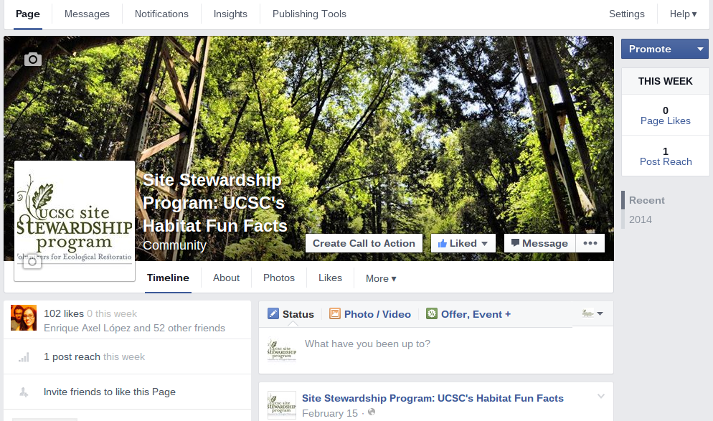
Site Stewardship Facebok Page
Appendix B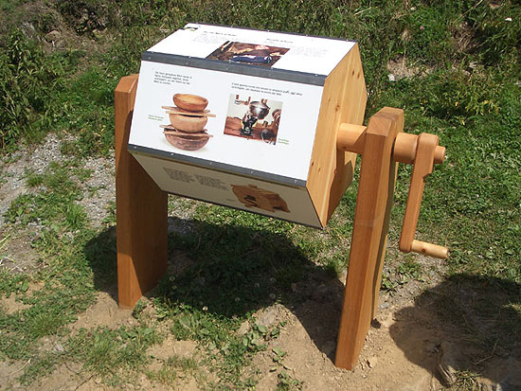
Prototype of Interpretive Sign
Appendix C 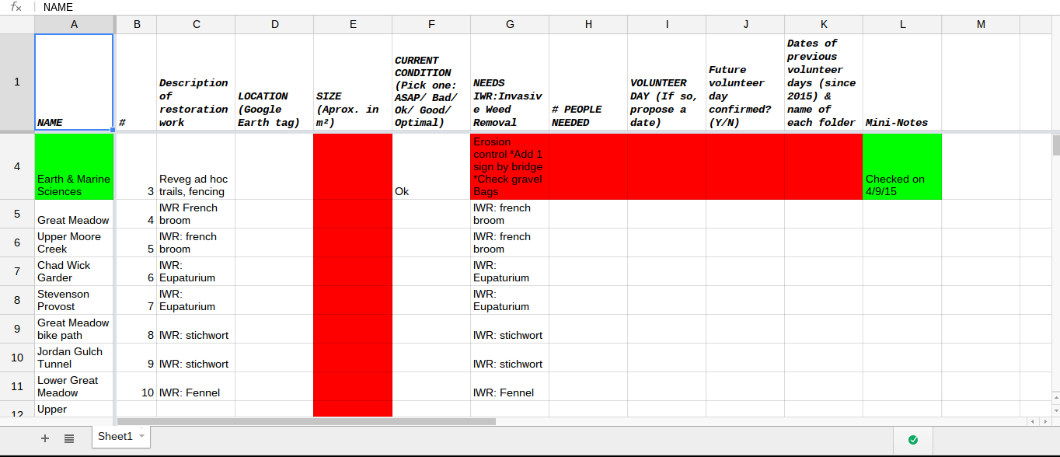
Monitoring Sites Spreadsheet

Appendix D
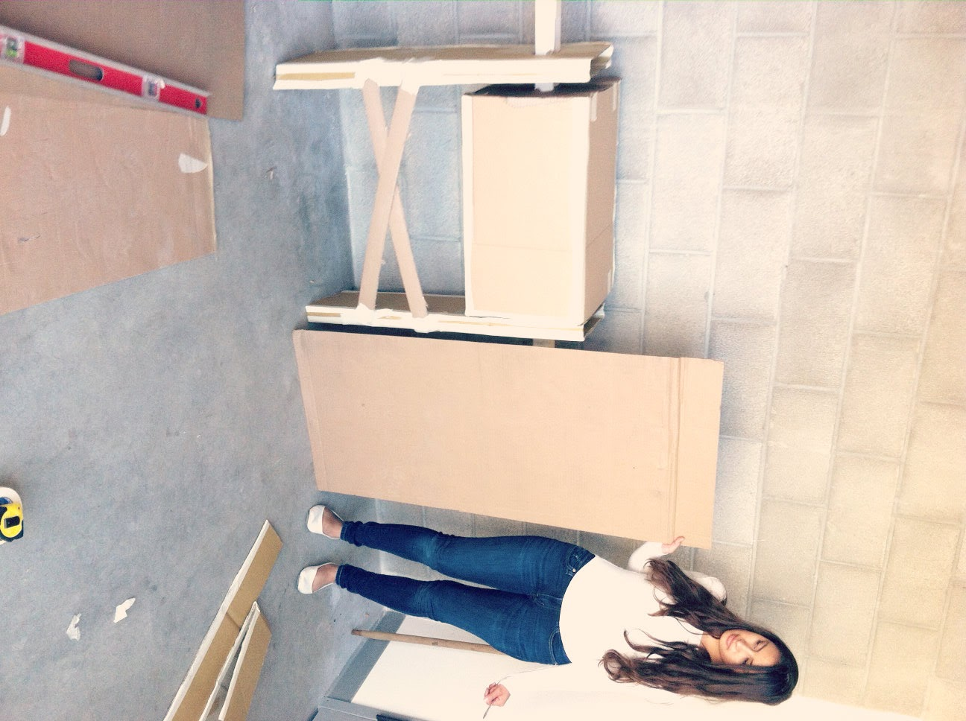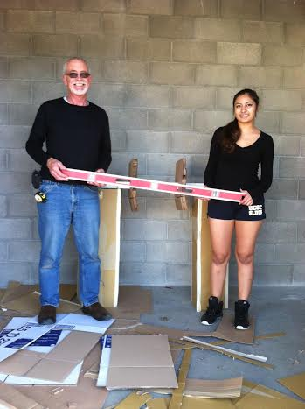
Cardboard version of the sign in comparison to the space occupied by a regular flat sign.
Dave Roe and Gabriela Mazzarello.
Appendix E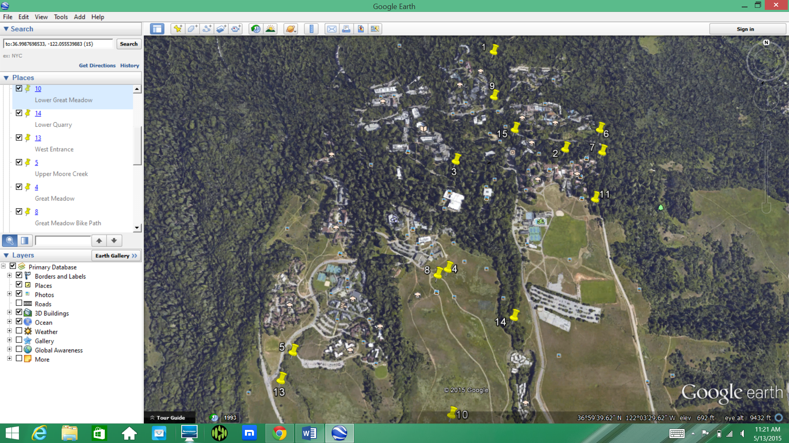
Locations of some of the sites on Google Earth, 2014
Appendix F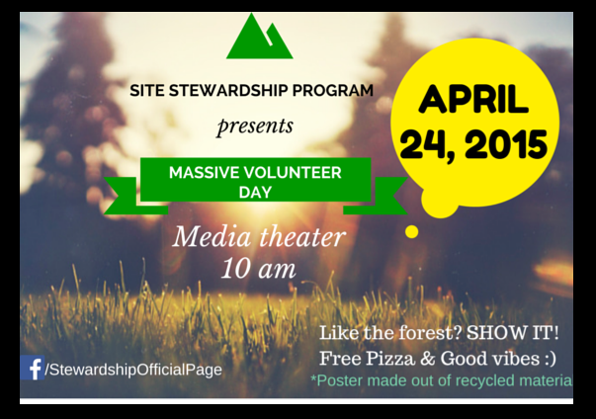
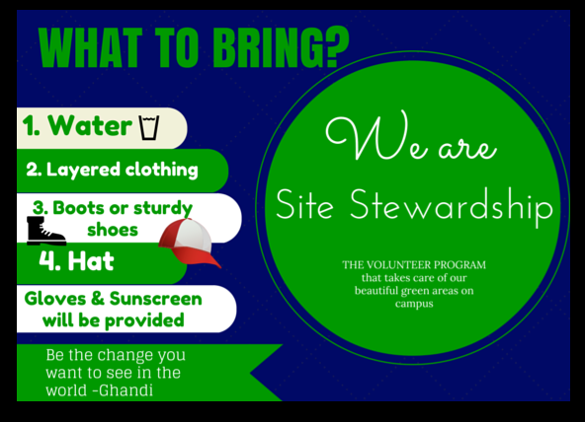
New Flyer for SSP (2 sided)
Appendix G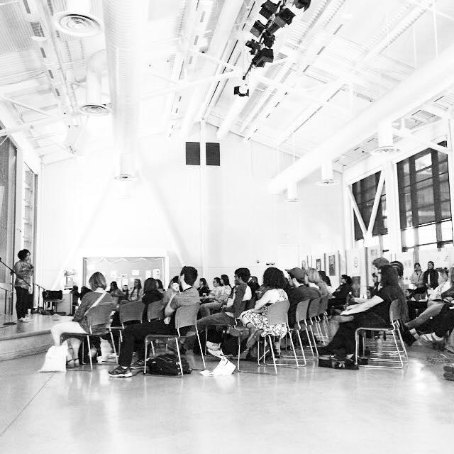
Earth Summit Volunteer, 2015
Appendix H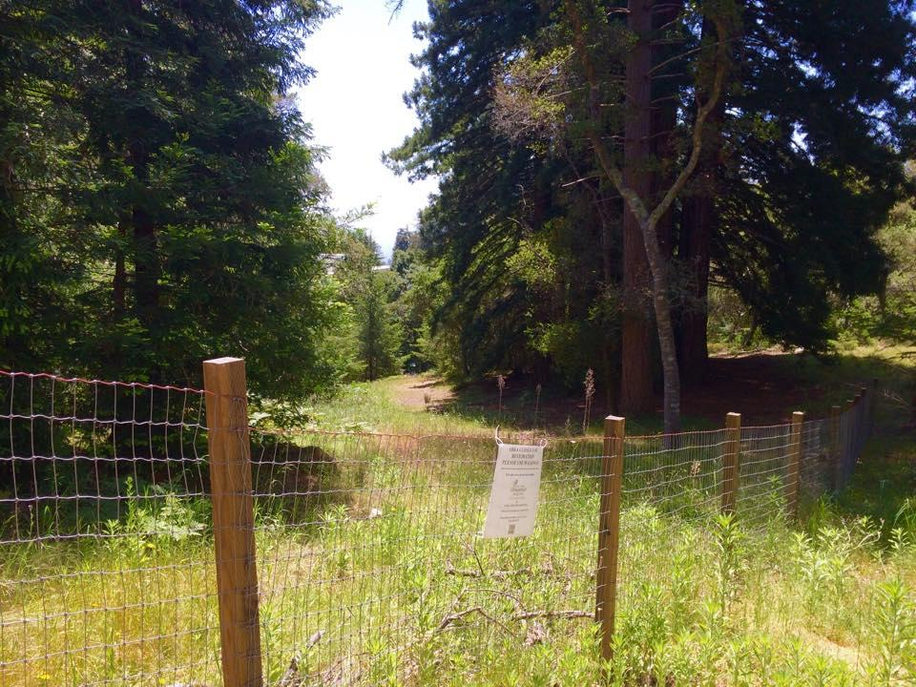
Earth and Marine Sciences Restoration Site, 2015
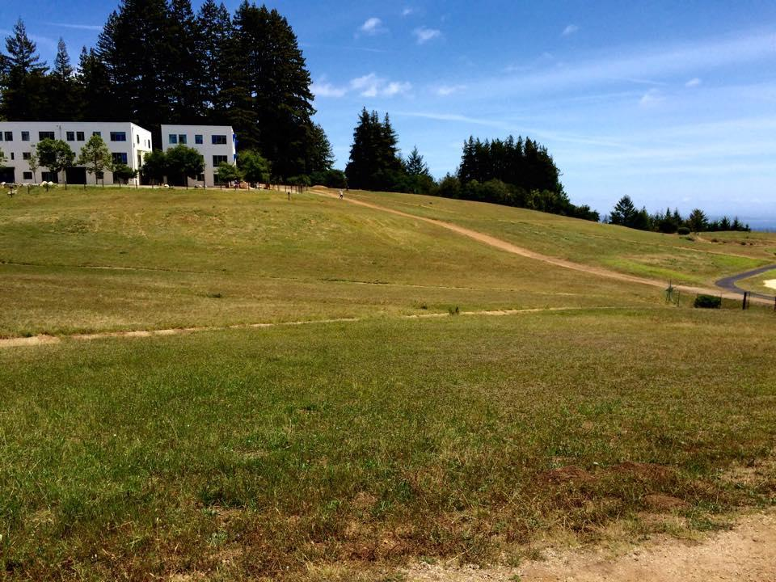
Cowell Meadow Restoration Site, 2015
References

- "Enrollment Headcount Since 1966." UCSC Data Warehouse
(n.d.): n. pag. 19 May 2014. Web.
http://planning.ucsc.edu/irps/historicalData/HeadcountEnrollmentHistory.pdf

- “Facts & Figures.” UC Santa Cruz
N.p., 2015. Web.
http://www.ucsc.edu/about/facts-figures.html

- “Habitat Types and Sensitive Species” UCSC Campus Natural Reserve
N.p., 2013. Web.
http://ucsccampusnaturalreserve.blogspot.com/2013/05/habitat-types-and-sensitive-species.html

- "Land, Habitat, and Watershed." - Blueprint for a Sustainable Campus.
N.p., n.d. Web. 04 June 2015.
http://www.blueprint.enviroslug.org/land-habitat-and-watershed.html#/

- “Voluntary environmental initiatives and sustainable industry”
Paton, B. (2000).

- "Rural Roads." EPA. Environmental Protection Agency, 27 June 2012.
Web. 04 June 2015.
http://www.epa.gov/agriculture/trur.html#unpavedroadsinforests

- "The CADDIS Urbanization Module." Environmental Protection Agency
(n.d.): n. pag. Web.
http://www.epa.gov/caddis/pdf/urban_module_final_draft.pdf

- "The UC Santa Cruz Budget – A Bird’s Eye View." UC Santa Cruz
(n.d.): n. pag. 2015. Web.
http://planning.ucsc.edu/budget/Reports/profile2014.pdf

